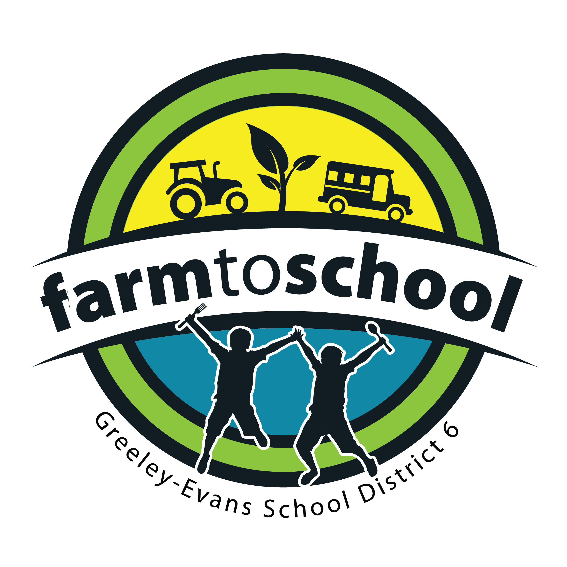

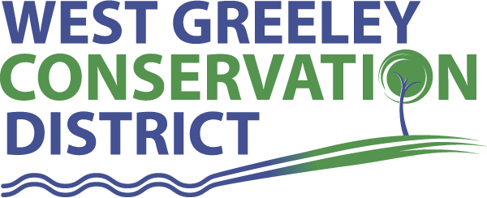

District 6, Nutrition Services Garden Tower Project
- Funded by the West Greeley Conservation District
- 14 Garden Towers purchased
  - Gardens demonstrate cycle of food, from planting seeds through harvesting and composting organic materials with the vermiculture (composting worms) center column to return nutrients to the soil
- Soil donations of 6 cubic feet per tower secured by District 6 from local hardware stores
- Seed donations from numerous seed companies secured by District 6
- Planting guides, maintenance, and associated lesson plans provided by the Garden Tower Project
- Ability to extend Colorado growing season due to garden tower mobility
**Seeking funds or materials for six (6) casters and wheel sets** The cost for one caster wheel kit is $109. (If two-four wheel kits are purchased, they would cost $99.19 each.) The premium kit includes a USA-made laser-cut and double powder coated heavyweight steel support structure, hardware, and three heavy duty double locking (rotational axis locking) triple ball bearing black casters. Specs: 220lb load rating per caster, 3” premium extra-wide, smooth polyurethane ball bearing wheels, lifetime warrantied against mechanical failure (functionality of the bearings, braking systems, integrity of the wheels, etc.). For more information about the wheels you can visit: https://gardentowerproject.com/product/garden-tower-2-premium-caster-wheel-kit-double-locking-black-caster-versions/ To donate, please contact: Natalie Leffler Rehurek, 970.348.6645 or NLeffler@greeleyschools.org
Project:
- Schools will complete and submit an interest form to request a garden tower to D6 Nutrition Services, Farm to School Team explaining how they intend to use the garden tower within their classroom and/or school, and how long they would like to house the garden tower (one semester or full school year)
- Preference given to schools:
  - without a school garden
  - with no or limited access to growing space (like Fred Tjardes- all pavement, no access to in-ground growing/garden)
  - Elementary schools
  - Integrating gardening/food/agricultural education and lessons (intent of use)
- Future Farmers of America (FFA) students from Greeley West High School will be partnered with each garden tower to provide guidance and assistance in establishing the garden tower, ongoing maintenance, and finally harvesting and completing the growing cycle
- After harvesting from the garden tower, Nutrition Services, Wellness Team and Farm to School Team will hold a “Chef in the Classroom” session, a nutrition education and hands-on cooking class offered to K-12 student, and prepare a recipe in class utilizing the produce grown in the tower.

