West Greeley Conservation District
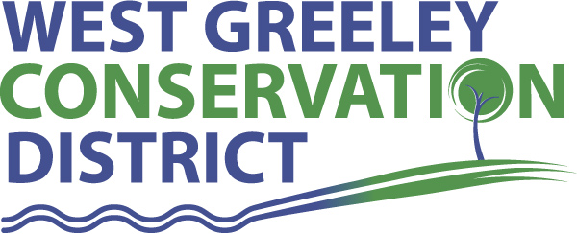
Board of Supervisors
Meeting Agenda
Monday, August 13, 2018
Board Meeting @ 11 am
Houston Gardens
515 23rd Avenue
Greeley, CO 80634
(970) 356.8097 ext 140

Welcome, roll call, and meeting called to order:
Introduction of Guests:
Approval of Board Meeting Minutes from Regular Meeting July 2018
( ) ( )
Approval of July 2018 Treasurers Report and Financial Statements
( ) ( )
Approval of Accounts Payable for July 2018
( ) ( )
Staff and Houston Garden Report
- Staff
- Liz Schneider, Conservation Technician
- Jasen Kettle, Houston Garden Coordinator
- Kristi Helzer, Community Outreach/Ed Coordinator
- Bruce Cameron, Seasonal Conservation Technician
Partner Reports
NRCS Report: Rusty Norrie-DC

- Referrals: None
- Report:

CSU Extension Report: Keith Maxey/ County Director

New Business/Request for Financial Support

- J. Leone Trip to Portland, OR – assess options for Houston Garden Community Garden Plots
- CFA – Colorado Reader Sponsorship $5000
( ) ( )
- Rancher COY Nomination – Jim Sturrock
- Greeley Creative District – Ag Feast ($1000) Thursday, August 30 ( ) ( )
- Envirothon Host Site ( ) ( )
- Weld County CSU Extension Sponsorship Weld Ag Leadership & Ambassador Program ($1100) ( ) ( )
- USPWSA – Any Suggested resolutions to be brought forth to September Watershed Meeting
- Cost Share: Joaquin Gallegos ( ) ( )
- Houston Garden – Suggestions for on site green house
- Hail Damage - Yukon
Unfinished Business

- Transfer of funds from 1st National and First Farm Banks to Farmer’s Bank
- PERA Update and Opt-Out Options (No changes)
- Rocky Mountain Deposition Sponsorship – tabled to September (Bill Hammerich)
- Evans Chamber BAH – July 19 @ HG recap
- WGCD BBQ – August 10 recap
- Greeley Chamber Ag Tour – August 17 – Agenda attached
Weld County Referrals ( ) ( )

- Kenneth & Connie Miller – Two lot recorded exemption
- Dean W Hagemeister – Property split
- Green River Dev Co LP – Subx for oil and gas support and service
- Tri-State Generation & Transmission Association, Inc – SSDPU electrical transmission line
- Michael Lukas & Jennifer Marie Rae – Subdivision exemption for financing purposes
- Russell Baker & Georgia Gilmore – SSDPU truck parking
- Michael R Lordemann Revocable Trust – Two lot recorded exemption
- William H Carlsen & Charles L Achziger – Amend Lots A and B RECX15-0086
- Foreb LLC – Amended SPR warehouse addition associated with auto body repair
- John & Alice Kuersten – SSDPU – use by right, accessory use for trucks, etc
Annexation Notifications:
- Town of Severance – Severance South 6th Filing
- Greeley 257 Spur Enclave Annexation
- Town of Pierce REP Annexation
- Town of Kersy Cecil’s Kersey Farm Annexation
- Minor Subdivision Plat

Notice of Public Hearing:
- Land Use Code for Western Truck Body Shop

Reclamation Permit (112c) Construction Materials ( ) ( )
- Wells Trucking, LLC Timmerman/Wells Pit M2015005
Reclamation Permit (112) ( ) ( )

Construction Material (111) Permit ( ) ( )
- Ames Construction Inc, Ard Property Borrow

BIO SOLID PERMIT
- None ( ) ( )

Announcements and Reminders
- Board Members should turn in mileage reimbursements.
- Next Board Meeting: September 10
- BBQ – August 10, 2018
- Holiday – September 3 for Labor Day
- Houston Garden Fall Season Hours Begin September 1 (8-4/S-Sat)
Executive Session: Time is set aside to adjourn the open meeting and go into executive session in accordance with (CRS 24-6-402 (4) (f).
1:00 pm Adjournment

Board Members Present Partners/Guests/Staff Present

( ) John Leone ( ) NRCS – Rusty Norrie
( ) Randy Miller ( ) CSU/Extension – Keith Maxey
( ) Lenny Simpson ( ) Liz Schneider
( ) Tony Becker ( ) Jasen Kettle
( ) Allen Beloin ( ) Kristi Helzer
( ) Richard Foose, Member Emeritus ( ) Bruce Cameron

