West Greeley Conservation District
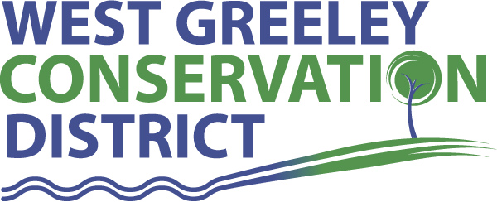
Board of Supervisors
Meeting Agenda

Wednesday, December 4, 2019

Board Meeting @ 4:00 pm

Gourmet Grub
2118 35th Avenue
Greeley, CO 80634

Welcome, roll call, and meeting called to order:
Introduction of Guests: Alan Holmberg, CPA/Anderson & Whitney
Approval of Board Meeting Minutes from Regular Meeting November 2019
( ) ( )
Approval of November 2019 Treasurers Report and Financial Statements
( ) ( )
Approval of Accounts Payable for November 2019
( ) ( )
Staff and Houston Garden Report
- Staff
- Liz Schneider, Conservation Technician

- Jasen Kettle, Houston Garden Coordinator

- Kristi Helzer, Community Outreach/Ed Coordinator

- Bruce Cameron, Seasonal Conservation Technician

- Taylor Webb, Office Assistant

- Ashley Follis, Office Assistant

- Ryan Kapperman, Conservation Technician Intern

Partner Reports
NRCS Report: Sam Adams, DC/NRCS

- Referrals:
- Report:

CSU Extension Report: Keith Maxey/ County Director

New Business/Request for Financial Support

- 2020 Budget and Transmittal Document Approval ( ) ( )
- Houston Garden: ( ) ( )
- Capital Equipment Purchase: $7190.48
(Kubota Z-trak)
- Bonnell Fencing Proposal: $600+/-
(Repairs)
- Petition Into District ( ) ( )
Emily Decosta
4507 W 6th Street
Greeley, CO 80634
- Cost Share Increase for Fencing ($5k up to $10k) ( ) ( )
- Weld County Weeds – Grant Application Partner
- Roy Hall, AC/NRCS Retirement Party Info
- 2020 HSA Maximum Contribution Limits ($3,550) ( ) ( )
- Partners in Ag / Farm Show Scholarships ( ) ( )
- Christmas Bonuses ( ) ( )

Unfinished Business

- Green House Update
- NACD Meeting February 8-12 Las Vegas, NV held at Bally’s – please confirm intent to attend for registration

Weld County Referrals ( ) ( )

- James Ochsner Trust ZPTT19-0002 Zoning Permit for a telecommunication tower
- Jose Rivas RECX19-0152 Two lot recorded exemption
- Loyd Farms RECX19-0149 Two lot recorded exemption
- David Leonard Stromberger RECX19-0148 Four lot recorded exemption
- Edward D Simpson RECX19-0142 Two lot recorded exemption
- Ronald Richardson RECX19-0144 Two lot recorded exemption

Town of Kersey
Town of Evans
Town of Severance

Annexation Notifications:
- None
Reclamation Permit (112c)

BIO SOLID PERMIT
- None

Announcements and Reminders
- Board Members should turn in mileage Reimbursements.
- Next Meeting is Monday, January 13, 2020 @ WGCD office
- Colorado Farm Show January 28-30, 2020
- NACD, Las Vegas February 8-12, 2020

Executive Session: Time is set aside to adjourn the open meeting and go into executive session in accordance with (CRS 24-6-402 (4) (f).
1:00 pm Adjournment

Board Members Present

( ) John Leone
( ) Randy Miller
( ) Lenny Simpson
( ) Tony Becker
( ) Allen Beloin

Staff Members Present

( ) Liz Schneider
( ) Jasen Kettle
( ) Kristi Helzer
( ) Bruce Cameron
( ) Kandee Nourse
( ) Taylor Webb
( ) Ashley Follis
( ) Ryan Kapperman
( ) Adam Schott

Partners Present

( ) Sam Adams - DC/NRCS
( ) Keith Maxey - CSU/Extension

Guests Present

( ) Alan Holmberg

