West Greeley Conservation District
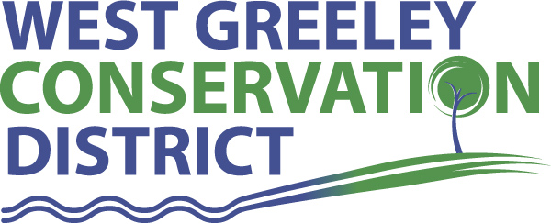
Board of Supervisors
Meeting Agenda
Monday, July 9, 2018
Board Meeting @ 11 am
Houston Gardens
515 23rd Avenue
Greeley, CO 80634
(970) 356.8097 ext 140

Welcome, roll call, and meeting called to order:
Introduction of Guests: Samantha Maxwell, Greeley West FFA/Ag Techer; Clay
Carlson/ CSU Livestock Judging Team
Approval of Board Meeting Minutes from Regular Meeting June 2018
( ) ( )
Approval of June 2018 Treasurers Report and Financial Statements
( ) ( )
Approval of Accounts Payable for June 2018
( ) ( )
Staff and Houston Garden Report
- Staff
- Liz Schneider, Conservation Technician
- Jasen Kettle, Houston Garden Coordinator
- Kristi Helzer, Community Outreach/Ed Coordinator
- Bruce Cameron, Seasonal Conservation Technician
Partner Reports
NRCS Report: Rusty Norrie-DC

- Referrals: None
- Report:

CSU Extension Report: Keith Maxey/ County Director

New Business/Request for Financial Support
- CRP Recovery Cost Share
- John Smedley
- Annual Board Meeting – November 8, 2018 @ Island Grove
- CSU Livestock Judging Team Sponsorship ($2500)– Clay Carlson
( ) ( )
- Mineral Right Forms
- Increase Jasen Kettle’s Credit Card Limit ($2500) ( ) ( )
- Discussion and Consideration of Additional Small Equipment
( ) ( )
a.)
b.)
c.)
- Greeley Chamber Ag Tour Sponsorship ($2500) – ( ) ( )
Unfinished Business

- Discussions for options of CD’s and various investment options
- Coalbank Dam Inspection Report
- TCP – NRCS Update
- PERA Update and Opt-Out Options (No changes)
- Houston Garden:
Sprinkler System Update
- Rocky Mountain Deposition Sponsorship
- USPWS – June 20 @ Keenesburg - recap
- Camp Rocky Update – July 9-15
- Evans Chamber BAH – July 19 @ HG
- Pawnee Buttes Grassland Tour/SRM June 20-21
- WGCD BBQ – August 10
Weld County Referrals ( ) ( )

- One Diamond LLC – Two lot recorded exemption
- DJ Eaton LLC – Four lot recorded exemption
- Todd M & Lisa Arnold – Two lot recorded exemption
- DCP Operating Company – High pressure natural gas pipeline
- DCP Operating Company – High pressure natural gas pipeline
- Cheryl Sweet Trust – Brewery/Pub
- Les Matson Construction Inc c/o Brian Hartman – Construction vehicles/equipment storage
- Outrigger DJ Operating LLC – Natural gas processing facility
- Owl Creek Land Investments – Two lot recorded exemption
- DCP Operating Company – Natural gas pipeline
- Richard & Jean Dumm/Martie & Richard Dumm Jr/Dairy Tech Inc. – Site Specific for dairy feeding operation
- Christian Petersheim – Two lot recorded exemption
- Kendall & Megan Wren – Subdivision exemption for financing
- De Jager 2007 Living Trust – Subdivision for Financing
- Corie & Paige Baessler, c/o CB Signature Homes – Office for construction company in Ag Zone
- Donaldson and Company – Two lot recorded exemption
Annexation Referral: Millissa Berry, Great Western 7th Annexation, Windsor

Reclamation Permit (112c) Construction Materials ( ) ( )

Reclamation Permit (112) ( ) ( )

Construction Material Special (111) Operation Reclamation Permit ( ) ( )

BIO SOLID PERMIT
- None ( ) ( )

Announcements and Reminders
- Board Members should turn in mileage reimbursements.
- Next Board Meeting: August 13
- BBQ – August 10, 2018

Executive Session: Time is set aside to adjourn the open meeting and go into executive session in accordance with (CRS 24-6-402 (4) (f).
1:00 pm Adjournment

Board Members Present Partners/Guests Present

( ) John Leone ( ) NRCS – Rusty Norrie
( ) Randy Miller ( ) CSU/Extension – Keith Maxey
( ) Lenny Simpson ( ) Samantha Maxwell
( ) Tony Becker ( )
( ) Allen Beloin ( )
( ) Richard Foose, Member Emeritus ( )

