West Greeley Conservation District
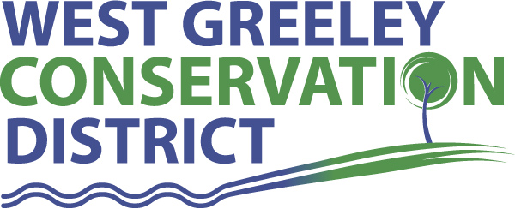
Board of Supervisors
Meeting Agenda
Monday, June 11, 2018
Coalbank Dam Inspection @ 9am
Board Meeting @ 11 am
Houston Gardens
515 23rd Avenue
Greeley, CO 80634

Welcome, roll call, and meeting called to order:
Introduction of Guests: Tina Booton/WC Weeds
Approval of Board Meeting Minutes from Regular Meeting May 2018
( ) ( )
Approval of May 2018 Treasurers Report and Financial Statements
( ) ( )
Approval of Accounts Payable for May 2018
( ) ( )
Staff and Houston Garden Report
- Staff
- Liz Schneider, Conservation Technician
- Jasen Kettle, Houston Garden Coordinator
- Bruce Cameron, Seasonal Conservation Technician

Partner Reports
NRCS Report: Will Owsley-NRCS

- Referrals: Leonard Ball (CTA) Konig Farms ( CTA)
(1) (2)
- Report:

CSU Extension Report: Keith Maxey/ County Director

New Business/Request for Financial Support
- Small Grant Applications
- Greeley/Evans School District (ESY-Exceptional students) $500 for bussing to Houston Garden ( ) ( )
- Greeley West Science Dept – Virtual Reality Earth $1710
( ) ( )
- Soccer Without Borders $1200 ( ) ( )
- Petition into District requests:
- Hockley, Julie
- Rivera, Ramiro
- (2)

- Wildlife Collection System (Guzzler) – Rough draft of Cost Share Application (1) (2)
- Tree planter/fabric mulch layer update
- Discussions for options of CD’s and various investment options
- Twine Collection Support and Approval for Support in our Area ($200)

Unfinished Business

- TCP – NRCS Update
- PERA Update and Opt-Out Options
- Houston Garden:
Sprinkler System Update
- Rocky Mountain Deposition Sponsorship Revisit in July
- USPWS – June 20 @ Keenesburg – By Law Review
- D-6 Garden Ed Project Update ( ) ( )
- Building Compliance Update
- Camp Rocky Update – July 9-15
Weld County Referrals ( ) ( )

- Summit Midstream Niobrara, LLC – Mineral Resource Development Facility
- Curtis Martinez & Longs Peak Dairy LLC – Lot line adjustment
- Alan & Terezia M Axton – Two lot recorded exemption
- Ryan Hostetler – Four lot recorded exemption
- Miller HFI LLC – Two lot recorded exemption
- Erica Arnold – Two lot recorded exemption
- Brian Allmer – Two lot recorded exemption
- Richard L Reinick Sr – Two lot recorded exemption
- Oneok, Inc – High pressure natural gas pipeline
- Tricycle Lane Texas, LLC – Mineral resource development
- Joseph F & Janet L Timko – Two lot recorded exemption
Annexation Referral:

Reclamation Permit (112c) Construction Materials ( ) ( )
Aggregate Industries WCR Inc M-1999-098
Reclamation Permit (112) ( ) ( )

Construction Material Special (111) Operation Reclamation Permit ( ) ( )

BIO SOLID PERMIT
- None ( ) ( )

Announcements and Reminders
- Board Members should turn in mileage reimbursements.
- Next Board Meeting: June 11/Dam Inspection and Meeting to follow at Houston Garden
- Pawnee Buttes Grassland Tour/SRM June 20-21
- Camp Rocky – July 9-15
- Evans Chamber Business After Hours - July 17, 2018
- BBQ – August 10, 2018
- USPWS – June 20 @ Keenesburg

Executive Session: Time is set aside to adjourn the open meeting and go into executive session in accordance with (CRS 24-6-402 (4) (f).
1:00 pm Adjournment

Board Members Present Partners/Guests Present

( ) John Leone ( ) NRCS – Rusty Norrie
( ) Randy Miller ( ) CSU/Extension – Keith Maxey
( ) Lenny Simpson ( ) NRCS – Will Owsley
( ) Tony Becker ( ) Tina Booton
( ) Allen Beloin ( )
( ) Richard Foose, Member Emeritus ( )

