West Greeley Conservation District
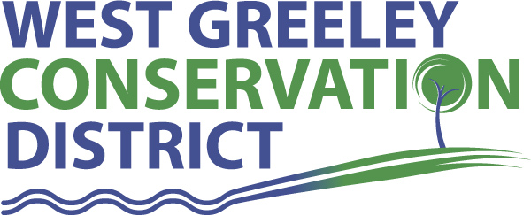
Board of Supervisors
Meeting Agenda

Monday, June 8, 2020

9:00 a.m. Coalbank Dam

11:00 a.m.
Houston Garden
515 23rd Ave
Greeley, CO 80631

Welcome, roll call, and meeting called to order:
Introduction of Guests: Tina Booton, Supervisor for WC Weed Division
Jeff Rasmussen, CED/FSA USDA Service Center, Brian Foss, City of Thornton
Approval of Board Meeting Minutes from Regular Meeting May 2020
( ) ( )
Approval of May 2020 Treasurers Report and Financial Statements
( ) ( )
Approval of Accounts Payable for May2020
( ) ( )
Staff Reports
- Staff
- Liz Schneider, Conservation Technician

- Jasen Kettle, Houston Garden Coordinator

- Kristi Helzer, Community Outreach/Ed Coordinator

- LeRoy D. Hall, Conservation Technician

- Bruce Cameron, Seasonal Conservation Technician

- Taylor Webb, Office Assistant

Partner Reports
NRCS Report: Sam Adams, DC/NRCS

- Referrals:
- Report:

CSU Extension Report: Keith Maxey/ County Director

New Business/Request for Financial Support

- Menjivar Quote ($5400) five trees, stumps and cleanup ( ) ( )
- Discussion on activities at Houston Garden

Unfinished Business

- Growling Bear / Halcyon Scope of Project
- Symposium Update

Weld County Referrals ( ) ( )

- Dennis and Cathy Shulte RECX20-0061 * Two lot recorded exemption
- Betty Pappenheim RECX20-0062 * Two lot recorded exemption
- Long’s Peak Dairy RECX20-0060 * Two lot recorded exemption
- Donald and Vicki Sheller RES20-0004 * Resubdivision to consolidate Lots 4-10, Block 4 of the Briggsdale Townsite into two lots
- Legacy Farm LLC RECX20-0065 * Four Lot Recorded Exemption
- Ryan Zigray RECX20-0066 * Two Lot Recorded Exemption
- Marlene Hale RECX20-0067 * Two Lot Recorded Exemption
- Willard T Burbach RECX20-0070 * Two Lot Recorded Exemption
- Conestoga Farm Ground LLC RECX20-0071 * Four Lot Recorded Exemption

Town of Kersey
Town of Evans
Town of Severance

Annexation Notifications:
- None
Reclamation Permit (112)
- Weld County Public Works has applied for a Regular 112 reclamation permit to conduct the extraction of construction materials Koskie Site M2014024
- Kiewit Infrastructure Co has applied for a regular 112 reclamation permit to conduct the extraction of construction materials. The applicant proposes to reclaim the affected land to rangeland use. Kiewit Carr Sand & Gravel

BIO SOLID PERMIT
- None
Announcements and Reminders
- Board Members should turn in mileage Reimbursements.
- Next Meeting is Monday, July 13 @ Houston Garden
- Office closed Friday, July 3 in observance of Independence Day

Executive Session: Time is set aside to adjourn the open meeting and go into executive session in accordance with (CRS 24-6-402 (4) (f).
1:00 pm Adjournment

Board Members Present Partners Present

( ) John Leone ( ) Sam Adams – DC/NRCS
( ) Randy Miller ( ) Keith Maxey – ED/CSU Weld County Extension
( ) Lenny Simpson
( ) Tony Becker
( ) Allen Beloin

Staff Members Present Guests Present

( ) Liz Schneider ( ) Jeff Rasmussen, CED/FSA
( ) Jasen Kettle ( ) Brian Foss, City of Thornton
( ) Kristi Helzer ( ) Tina Booton, Supervisor/WC Weeds Div
( ) Bruce Cameron
( ) Kandee Nourse
( ) Taylor Webb
( ) LeRoy “Roy” Hall
( )

