West Greeley Conservation District
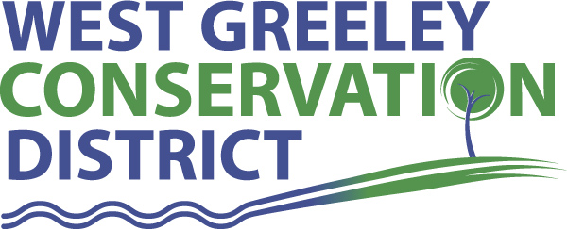
Board of Supervisors
Meeting Agenda

Monday, May 11, 2020

11:00 a.m.
Houston Garden
515 23rd Ave
Greeley, CO 80631

Welcome, roll call, and meeting called to order:
Introduction of Guests:
Approval of Board Meeting Minutes from Regular Meeting April 2020
( ) ( )
Approval of April 2020 Treasurers Report and Financial Statements
( ) ( )
Approval of Accounts Payable for April 2020
( ) ( )
Staff and Houston Garden Report
- Staff
- Liz Schneider, Conservation Technician

- Jasen Kettle, Houston Garden Coordinator

- Kristi Helzer, Community Outreach/Ed Coordinator

- LeRoy D. Hall, Conservation Technician

- Bruce Cameron, Seasonal Conservation Technician

- Ryan Kapperman, Seasonal Conservation Technician

- Taylor Webb, Office Assistant

Partner Reports
NRCS Report: Sam Adams, DC/NRCS

- Referrals:
- Report:

CSU Extension Report: Keith Maxey/ County Director

New Business/Request for Financial Support

- Oath of Office
J. Leone L. Simpson A. Becker
- Windbreak Cost Share - ( ) ( )
Tyler Novinger, Ault $3500
- Lateral Ditch Cost Share – ( ) ( )
Wadlin Lateral / Dan Swanson $50,000
- Lamar Amendment to Lease Agreement – ( ) ( )
month to month i/o annually
- Coalbank Dam Inspection – Monday June 8 @ 9 am

Unfinished Business

- Growling Bear Design Preliminary Estimate for Pavilion $200-$300k
- Tree Sale Pick up: April 29, 30 and May 1 Recap
- Symposium Update

Weld County Referrals ( ) ( )

- Shon E Anderson 1AMRECX20-13-0022 Amended recorded Exemption to amend Boundary of Lot in Conjunction with 1AMRECX20-13-0021
- Bernie & Marcia Ellis RECX20-0057 Two Lot Recorded Exemption
- Barton Land and Cattle, inc. RECX20-0054 Two Lot Recorded Exemption (Denial)
- David Keiser & Harry Strohauer RECX20-0053 Two Lot Recorded Exemption
- Philip & Robin Morgan RECX20-0051 Two Lot Recorded Exemption
- Luis M Flores Chavarria RECX20-0050 Two Lot Recorded Exemption
- Brian S Barton RECX20-0047 Two Lot Recorded Exemption
- LAD Farm LLC 1AMRECX20-13-0021 Amended Recorded Exemption to Amend Boundary of Lot A in Conjunction with 1AMRECX20-13-0022
- Lelyn Larson 1AMRECX20-12-0074 Amended Recorded Exemption to Amend Lot Lines of Lots A and B of Corrected RECX12-0074

Town of Kersey
Town of Evans
Town of Severance

Annexation Notifications:
- None
Reclamation Permit (112c)

BIO SOLID PERMIT
- None
Announcements and Reminders
- Board Members should turn in mileage Reimbursements.
- Next Meeting is Monday, June 8 @ Houston Garden
- Coalbank Dam Inspection is Monday, June 8 @ 9 am
Executive Session: Time is set aside to adjourn the open meeting and go into executive session in accordance with (CRS 24-6-402 (4) (f).
1:00 pm Adjournment

Board Members Present Partners Present

( ) John Leone ( ) Sam Adams – DC/NRCS
( ) Randy Miller ( ) Keith Maxey – ED/CSU Weld County Extension
( ) Lenny Simpson
( ) Tony Becker
( ) Allen Beloin

Staff Members Present Guests Present

( ) Liz Schneider ( )
( ) Jasen Kettle ( )
( ) Kristi Helzer ( )
( ) Bruce Cameron
( ) Kandee Nourse
( ) Taylor Webb
( ) Ashley Follis
( ) LeRoy “Roy” Hall
( )

