West Greeley Conservation District
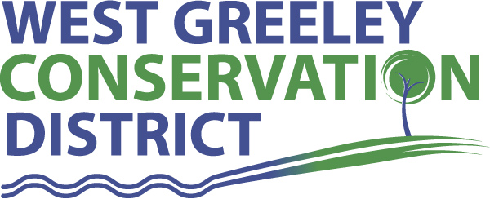
Board of Supervisors
Meeting Agenda
Monday, December 10, 2018
Board Meeting @ 4:00 pm
Gourmet Grub
2118 35th Avenue
Greeley, CO 80634

Welcome, roll call, and meeting called to order:
Introduction of Guests: Alan Holmberg, CPA-Anderson & Whitney; Mark Cronquist, Field Specialist-CSCB
Approval of Board Meeting Minutes from Regular Meeting November 2018
( ) ( )
Approval of November 2018 Treasurers Report and Financial Statements
( ) ( )
Approval of Accounts Payable for November 2018
( ) ( )
Staff and Houston Garden Report
- Staff
- Liz Schneider, Conservation Technician
- Jasen Kettle, Houston Garden Coordinator
- Kristi Helzer, Community Outreach/Ed Coordinator – Medical Leave of Absence
- Bruce Cameron, Seasonal Conservation Technician
Partner Reports
NRCS Report: Rusty Norrie-DC

- Referrals: Riverview Farms LLC (CTA) 380.4 acres
- Report:

CSU Extension Report: Keith Maxey/ County Director – not present

New Business/Request for Financial Support

- Cost Share Consideration: Bryan VanenBirge-Windbreak Cost Share $3500 ( ) ( )
- Weld County Weeds 2019 State Noxious Weed Fund Grant Applications (info only)
- Weld County Weeds 2019-2021 Collaboration at Pawnee National Grasslands – Reseeding/Purchase Seed ($900-$1500)
( ) ( )
- NWCWD - Plant Investment Surcharge Credit ( ) ( )
- Christmas Bonuses/Annual Leave Pay Out ( ) ( )

Unfinished Business

- 2019 Budget Approval - ( ) ( )
- 2018 GMC 3500HD Sierra Purchase Update
- NACD Annual Meeting – San Antonio, TX Feb 2-6, 2019
- New Vehicle Purchase - Discussion

Weld County Referrals ( ) ( )

- Krier, Michael & Mary c/o Expedition Water Solutions Colorado, LLC – USR18-0119 (Mineral Resource Development Facility)
- Bean Farm, LLC, Bean, Todd & Kristen – RECX18-0154 (Four lot recorded exemption)
- Rodgers, Alice & Jimmie – RECX18-0155 (Two lot recorded exemption)
- CMH Homes, Inc. – RECX18-0156 (Two lot recorded exemption)
- Scoggin, David n & Sharon R – RECX18-0158 (Two Lot recorded exemption)
- Thompson, Jeffery & Rhonda – RECX18-0157 (Two lot recorded exemption)
- Owens, Eileen B – RECX18-0159 (Four lot recorded exemption)
- Jones, Eric L – 1AMRECX18-04-3499 (Amend boundaries)
- Wanger, Clayton & Shanna – 1AMRECX18-06-4470 (Amendment to Lot)
- Fowler, Stan & Eleanor – 1AMRECX18-15-0155 (Amendment to Lot)
- Erickson, Nancy L – 1AMRECX18-78-327 (Amend boundaries)
- Turrentine, Brian – 1AMRECX18-96-1182 (Amendment to lot)
- Carr, Brian & Sarah – 1AMSUBX18-15-0035 ( Amendment to SUBX)

Annexation Notifications:
- None

Notice of Public Hearing:
- None

Reclamation Permit (112c) Construction Materials
- Tollgate Pit, File No. M-2018-060

Reclamation Permit (112)
- None
Construction Material (111) Permit
- None

BIO SOLID PERMIT
- None ( ) ( )

Announcements and Reminders
- Board Members should turn in mileage reimbursements.
- December Board Meeting: December 10 @ Gourmet Grub @ 4 PM
- Holiday – Veteran’s Day - Monday, November 12, 2018
- Holiday – Thanksgiving – November 22-23

Executive Session: Time is set aside to adjourn the open meeting and go into executive session in accordance with (CRS 24-6-402 (4) (f).
1:00 pm Adjournment

Board Members Present Partners/Guests/Staff Present

( ) John Leone ( ) NRCS – Rusty Norrie
( ) Randy Miller ( ) CSU/Extension – Keith Maxey
( ) Lenny Simpson ( ) Liz Schneider
( ) Tony Becker ( ) Jasen Kettle
( ) Allen Beloin ( ) Kristi Helzer
( ) Richard Foose, Member Emeritus ( ) Bruce Cameron

