West Greeley Conservation District
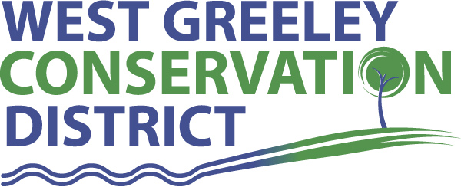
Board of Supervisors
Meeting Agenda

Monday, September 14, 2020

11:00 a.m.
Houston Garden
515 23rd Ave
Greeley, CO 80631

Welcome, roll call, and meeting called to order:
Introduction of Guests: Kelly Deitman, Halcyon Design LLC
Approval of Board Meeting Minutes from Regular Meeting August 2020
( ) ( )
Approval of August 2020 Treasurers Report and Financial Statements
( ) ( )
Approval of Accounts Payable for August 2020
( ) ( )
Staff Reports
- Staff
- Liz Schneider, Conservation Technician

- Jasen Kettle, Houston Garden Coordinator

- Kristi Helzer, Community Outreach/Ed Coordinator

- LeRoy D. Hall, Conservation Technician

- Bruce Cameron, Seasonal Conservation Technician

- Taylor Webb, Office Assistant

Partner Reports
NRCS Report: Sam Adams, DC/NRCS

- Referrals: ( ) ( )
- Report:

CSU Extension Report: Keith Maxey/ County Director

New Business/Request for Financial Support

- Cement Ditch Cost Share:
Gallegos, Joaquin $500
- CD vs Money Market

Unfinished Business

- Growling Bear / Halcyon Update – Kelly Deitman
- Symposium Update
- Common Ground Webinar for Colorado SRM 2020 Annual Meeting

Weld County Referrals ( ) ( )

- Douglas & Deborah Duggan, c/o Amerigas Propane, L.P USR20-0023 Site Development Plan
- c/o Keiser David E. & Dale A RECX20-0102 Two Lot Recorded Exemption
- M & L Real Estate LLC RECX20-0100 Four Lot Recorded Exemption
- Doug Derr & Darwin Derr SPR20-0012 Site Plan Review for Derr Brothers Grading inc. Include screened parking staging and storage of heavy construction equipment.
- Louie & Gina Fabrizius RECX20-0107 Two Lot Recorded Exemption
- Philip & Bree Lukens RECX20-0104 Two Lot Recorded Exemption
- Philip & Bree Lukens RECX20-0105 Four Lot Recorded Exemption
- Philip & Bree Lukens RECX20-0106 Four Lot Recorded Exemption

Town of Kersey
- Amend Site Plan Conditions

Annexation Notifications:
- Town of Ault
- Town of LaSalle
- Town of Severance
Reclamation Permit
- None
Final Plat Application in Severance
- Kegerreis, Roger and Virginia

BIO SOLID PERMIT
- Veris Environmental LLC Permit No. DS2000006 for Duane Brown, RC Land in Pierce
- Veris Environmental LLC Permit No. DS2000003 for Duane Brown in Pierce
- Veris Environmental LLC Permit No. DS 2000005 for Duane Brown in Pierce

Announcements and Reminders
- Board Members should turn in mileage Reimbursements.
- Next Meeting is Tuesday, October 13 @ Greeley USDA Service Center

Executive Session: Time is set aside to adjourn the open meeting and go into executive session in accordance with (CRS 24-6-402 (4) (f).
1:00 pm Adjournment

Board Members Present Partners Present

( ) John Leone ( ) Sam Adams – DC/NRCS
( ) Randy Miller ( ) Keith Maxey – ED/CSU Weld County Extension
( ) Lenny Simpson ( ) Jeff Rasmussen – CED/FSA USDA Greeley Service Ctr
( ) Tony Becker
( ) Allen Beloin

Staff Members Present Guests Present

( ) Liz Schneider ( )
( ) Jasen Kettle ( )
( ) Kristi Helzer
( ) Bruce Cameron
( ) Kandee Nourse
( ) Taylor Webb
( ) LeRoy “Roy” Hall
( )

