West Greeley Conservation District
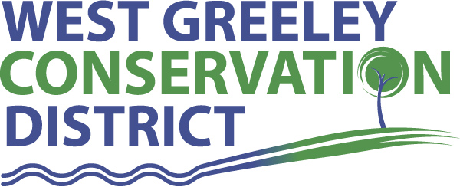
Board of Supervisors
Meeting Agenda
Monday, September 9, 2019
Board Meeting @ 11:00 a.m.
Houston Garden
515 23rd Avenue
Greeley, CO 80631

Welcome, roll call, and meeting called to order:
Introduction of Guests: CSU Livestock Judging Team Members – Bailey Schilling and Savannah Millburn
Approval of Board Meeting Minutes from Regular Meeting August 2019
( ) ( )
Approval of August 2019 Treasurers Report and Financial Statements
( ) ( )
Approval of Accounts Payable for August 2019
( ) ( )
Staff and Houston Garden Report
- Staff
- Liz Schneider, Conservation Technician

- Jasen Kettle, Houston Garden Coordinator

- Kristi Helzer, Community Outreach/Ed Coordinator

- Bruce Cameron, Seasonal Conservation Technician

Partner Reports
NRCS Report: Sam Adams, DC/NRCS

- Referrals:
- Report:

CSU Extension Report: Keith Maxey/ County Director

New Business/Request for Financial Support

- Upgrade/Replace Drives for Server ($3594) – ( ) ( )
- Houston Garden Fall 2019 Planting Phase ( $5000) ( ) ( )
- CSU Livestock Judging Team Report
- Cost Share Considerations:
- Duke Hemburger Livestock Well $10,000
- James McKay CRP Fencing $5000
( ) ( )

Unfinished Business

- Farmers Bank CD Maturity

Weld County Referrals ( ) ( )

- Deanna Swetzig SUBX19-0020 Subdivision exemption for a property line adjustment
- Roger and Cheryl Unrein ZPAG19-0002 Site specific development plan and zoning permit
- Nathan Trowbridge 1AMSUBX19-08-1128 Amended subdivision exemption
- Nathan Trowbridge 1AMRECX19-08-4777 Amended recorded exemption
- Brian Watkins and Kari Rydgren ZPAG19-0003 Site Specific development plan
- Herman E Libsack RECX19-0118 Two lot recorded exemption
- Wendy & Phillip Fleener ZPHB19-0005 Zoning Permit for a home office for accounting and tax prep
- Weld County USR19-0055 Site specific plan and use for a 280’ tall telecom tower
- Calvin Goza SUBX19-0017 Subdivision exemption for property line adjustment
- Tomara LLC SUBX19-0016 Subdivision exemption for an oil and gas support and service facility
- Tomara LLC USR19-0056 Site Specific Development Plan and Use for oil and gas support facility
- Elizabeth Wilson RECX19-0116 Two lot recorded exemption
- Timothy Young & Kendall Vonfeldt RECX19-0119 two lot recorded exemption
- Kristi Sitzman RECX19-0122 Two lot recorded exemption
- Alyson Carney c/o AB Underground LLC USR19-0051 Site specific development plan for underground pipeline
- LEP2 Holdings LLC PUDK19-0002 35 lot residential subdivision with 28 acres open space

Town of Severance
- Letter of Intent PUD Tracts 9 & 10
Town of Kersey
Town of Evans

Annexation Notifications:
- None
Reclamation Permit (112c)
Ashbaugh Gravel Pit Permit M-2005-060-SL01

Application for an Order to Establish and Approve a Comprehensive Drilling Plan
- Noble Energy Docket 191000612

BIO SOLID PERMIT
- None

Announcements and Reminders
- Board Members should turn in mileage reimbursements.
- Next Meeting is September 9, 2019 @ Houston Garden

Executive Session: Time is set aside to adjourn the open meeting and go into executive session in accordance with (CRS 24-6-402 (4) (f).
1:00 pm Adjournment

Board Members Present

( ) John Leone
( ) Randy Miller
( ) Lenny Simpson
( ) Tony Becker
( ) Allen Beloin

Staff Members Present
( ) Liz Schneider
( ) Jasen Kettle
( ) Kristi Helzer
( ) Bruce Cameron
( ) Kandee Nourse

Partners Present
( ) Sam Adams - DC/NRCS
( ) Keith Maxey - CSU/Extension

