West Greeley Conservation District
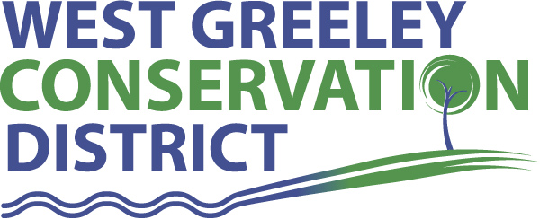
Board of Supervisors
Meeting Agenda

Monday, April 12, 2021

11:00 a.m.
Greeley USDA Service Center
4302 W 9th Street Rd
Greeley, CO 80634

Welcome, roll call, and meeting called to order:
Introduction of Guests:
Approval of Board Meeting Minutes from Regular Meeting March 2021
( ) ( )
Approval of March 2021 Treasurers Report and Financial Statements
( ) ( )
Approval of Accounts Payable for March 2021
( ) ( )
Staff Reports
- Staff
- Liz Schneider, Conservation Technician

- Jasen Kettle, Houston Garden Coordinator

- Kristi Helzer, Community Outreach/Ed Coordinator

- LeRoy D. Hall, Conservation Technician

- Taylor Webb, Office Assistant

- Bruce Cameron, Conservation Technician

Partner Reports
NRCS Report: Sam Adams DC/NRCS

- Referrals: ( ) ( )
- Report:

CSU Extension Report: Larry Hooker ED/CSU Extension

New Business/Request for Financial Support

- Scholarship Considerations and Discussions about Ranking
- Cost Share Consideration(s):
- CRP Recovery/Fencing and Livestock Well (Ed and Gloria Snell) $20,000 ( ) ( )
- Cement Ditch Repair (Joaquin Gallegos) $4725 ( ) ( )
- Petition Into The District: LeRoy D Hall (2701 W 26th Street Rd, Greeley, CO ( ) ( )
- Various House Bills and Show of Support – Discussion purposes
- WGCD Staff Time Assistance for NRCS/CRP – 10 hrs per month
- Aims Foundation Emergency Scholarship Assistance
- Confluence Institute ($2500)

Unfinished Business

- Growling Bear – Permit $4172.47 ( ) ( )
- Tree Sale Pickup is April 28-30 9:00-4:30
- Aims / Arbor and Earth Day Partnership Planting April 28
- Symposium Update

Weld County Referrals ( ) ( )

- Pawnee Ranch LLC LLA21-0008 Amend Boundary of lot D with adjacent Metes and Bounds Lots.
- Cynthia M Padilla ZPTT21-0001 Zoning Permit for Telecommunication Tower on one acre lease area for oil and gas facility
- CMH Homes Inc RES21-0001 Resubdivision to consolidate Lots 10-12, Block 15, and Lots 7-9, block 16 with adjacent vacated 3rd street and half the adjacent alleys.
- Taurino Martinez Cabrera ZPAG21-0005 Zoning Permit for uses in the Ag zone district.
- Dustin & Sandra Winter FFD21-0004 Family Farm Division

NOTICE of Filing Application for Colorado Mined Land Reclamation Permit
- Ames Construction, Inc has applied for a Special 111 reclamation permit (Rangeland)
- VIMA partners LLC has applied for a Special 111 Reclamation permit (Reservoir)
Annexation Notifications:
- Town of Johnstown Held Farm Annexation and Zoning

Town of Kersey
Town of Severance
- Final Plat for The Reserve Project Letter of Intent

BIO SOLID PERMIT
- None
Announcements and Reminders
- Board Members should turn in mileage Reimbursements.
- Next Meeting is May 10, 2021

Executive Session: Time is set aside to adjourn the open meeting and go into executive session in accordance with (CRS 24-6-402 (4) (f).
1:00 pm Adjournment

Board Members Present Partners Present

( ) John Leone ( ) Sam Adams – NRCS
( ) Randy Miller ( ) Larry Hooker – ED/CSU Weld County Extension
( ) Lenny Simpson ( ) Jeff Rasmussen – CED/FSA USDA Greeley Service Ctr
( ) Tony Becker ( )
( ) Allen Beloin

Staff Members Present Guests Present

( ) Liz Schneider ( )
( ) Jasen Kettle ( )
( ) Kristi Helzer
( ) Bruce Cameron
( ) Kandee Nourse
( ) Taylor Webb
( ) LeRoy “Roy” Hall
( )

