West Greeley Conservation District
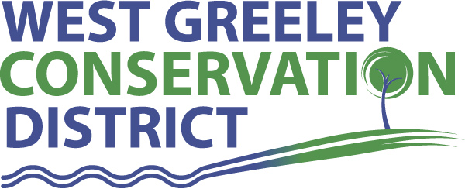
Board of Supervisors
Meeting Agenda

Monday, August 9, 2021

11:00 am
Houston Garden
515 23rd Avenue
Greeley, CO 80634

Welcome, roll call, and meeting called to order:
Introduction of Guests:
Approval of Board Meeting Minutes from Regular Meeting July 2021
( ) ( )
Approval of July 2021 Treasurers Report and Financial Statements
( ) ( )
Approval of Accounts Payable for July 2021
( ) ( )
Staff Reports
- Staff
- Liz Schneider, Conservation Technician

- Jasen Kettle, Houston Garden Coordinator

- Kristi Helzer, Community Outreach/Ed Coordinator

- LeRoy D. Hall, Conservation Technician

- Taylor Webb, Office Assistant

- Bruce Cameron, Conservation Technician

- Ryan Kapperman, Field Technician

Partner Reports
NRCS Report: Will Owsley, Resource Team Leader

- Report:

CSU Extension Report: Larry Hooker ED/CSU Extension

FSA Report: Jeff Rasmussen ED

New Business/Request for Financial Support

- Overhead Automatic Garage door opener at the shop for the east end - $1700-$2000 (Thompson Garage Door Company) ( ) ( )
- Petition Into the District – Amy Fanning ( ) ( )
- Cost Share Considerations:
- Brian Hill - CRP Recovery for Fencing 50% up to $10,000
Livestock Well 50% up to $10,000
- Burt Kross – CRP Recovery for Fencing 50% up to $10,000
Livestock Well 50% up to $10,000

- Colorado STAR Program
- Workman Comp Incident
- City of Thornton Voluntary Property Tax Payment $1606.56

Unfinished Business

- Concrete Work at the Shop
- Certificate of Deposit Maturity 08/27/2021
- Pavilion Retainage Final payment $8333.26 ( ) ( )
- Greenhouse Project (Prosipiant) Drawings and Recap of meeting
- Symposium/Annual Meeting Update (November 3-4) Double Tree
- C&S Rain Gutters (Houston Garden) $6703 ( ) ( )
- Tuff Shed (Houston Garden) $6322 ( ) ( )
Weld County Referrals ( ) ( )

- Wesley Basiliere PUDK21-0001 Planned Unit Development Sketch Plans for a Three lost of Residential and Ag uses
- Patrick Mcnear ZPTT21-003 Zoning Permit for Telecommunication Tower
- GWIP LLC SPR21-0007 Site Plan Review for Transload and Storage of Chemicals
- Circle B Land Company LLC SPR21-0008 Site Plan Review for Office Space, Outdoor Storage, and Parking Areas
- Circle B Land Company LLC COZ21-0003 Changing of Zone from the A to C-3(business commercial)
NRCS CTA Referrals
( ) ( )

NOTICE Consideration of 111 Construction Materials Reclamation Permit Application
- VIMA Partners LLC reclaim affected land to Reservoir use

Annexation Notifications:
- City of Greeley

Town of Kersey
- Minor Subdivision plat to create three lots in the Berryman Farm PUD
- Minor Subdivision plat to create two lots in the D Industrial District
Town of Severance

BIO SOLID PERMIT
- None
Announcements and Reminders
- Board Members should turn in mileage Reimbursements.
- Next Meeting is September 13 , 2021
- BBQ August 13, 2021
- Chamber Ag Tour August 27, 2021

Executive Session: Time is set aside to adjourn the open meeting and go into executive session in accordance with (CRS 24-6-402 (4) (f).
1:00 pm Adjournment

Board Members Present Partners Present

( ) John Leone ( ) Sam Adams – NRCS
( ) Randy Miller ( ) Larry Hooker – ED/CSU Weld County Extension
( ) Lenny Simpson ( ) Jeff Rasmussen – CED/FSA USDA Greeley Service Ctr
( ) Tony Becker ( ) Will Owsley - NRCS
( ) Allen Beloin

Staff Members Present Guests Present

( ) Liz Schneider ( )
( ) Jasen Kettle ( )
( ) Kristi Helzer
( ) Bruce Cameron
( ) Kandee Nourse
( ) Taylor Webb
( ) LeRoy “Roy” Hall
( ) Ryan Kapperman

