West Greeley Conservation District
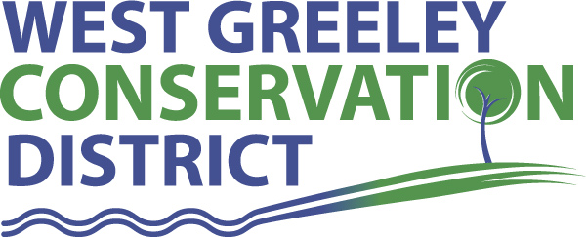
Board of Supervisors
Meeting Agenda

Monday, December 14, 2020

3:30 p.m.
Greeley USDA Service Center
4302 W 9th Street Rd
Greeley, CO 80634

Welcome, roll call, and meeting called to order:
Introduction of Guests:
Approval of Board Meeting Minutes from Regular Meeting November 2020
( ) ( )
Approval of November 2020 Treasurers Report and Financial Statements
( ) ( )
Approval of Accounts Payable for November 2020
( ) ( )
Staff Reports
- Staff
- Liz Schneider, Conservation Technician

- Jasen Kettle, Houston Garden Coordinator

- Kristi Helzer, Community Outreach/Ed Coordinator

- LeRoy D. Hall, Conservation Technician

- Bruce Cameron, Seasonal Conservation Technician

- Taylor Webb, Office Assistant

Partner Reports
NRCS Report: Sam Adams DC/NRCS

- Referrals: ( ) ( )
- Report:

CSU Extension Report: Keith Maxey/ County Director or Larry Hooker

New Business/Request for Financial Support

- 2021 Budget Approval ( ) ( )
- Petition Into the District: ( ) ( )
- Ball, Tammie L., Briggsdale, CO
43510 CR 69
- Lateral Ditch Cost Share - $20,200 ( ) ( )
- Roullard Lateral Ditch Co.
- Windbreak Cost Share - $2,500 ( ) ( )
- O’Leary, Amanda
- Rain Gauge Inventory Purchase $4,700 ( ) ( )
- Longs Peak Science Fair Sponsorship $1,250 ( ) ( )
- Smart Water Timer Cost Share Discussion
- Cost Share Application Inclusions for discussion
- Christmas Bonuses
- HSA limit for 2021 is $3,600

Unfinished Business

- Growling Bear – Permitting process began week of December 7; Brandon Munro is the Sr Project Manager; Dylan Jones is the Project Engineer
- Greenhouse Discussions estimated costs $42,700
- Houston Garden Improvements and Maintenance
- Sidewalk repairs and widening - $5,000
- New fencing and widening along west side of BGC - $3,300
- Interpretive Signage $8,000
- Pond Aeration System
- Swing Gate for Main Entrance
- Request from J. Baldwin of BGC for access to HG
- USDA Service Center Keying/Security System – on track

Weld County Referrals ( ) ( )

- William and Patricia Humphries (COC20-0004) Certificate of Compliance for Auxiliary Quarters.
- Bret and Nicole McCollum (RECX20-0084) Two Lot Recorded Exemption
- Darren and Taryn Sharp (1MUSR20-16-0045) Minor Amendment to Site Specific Development Plan to increase size of the storage yard from 17,000 square feet to 43,000 sq. ft. and add Two 40 foot steel containers in the A zone.
- Matthew and Heather Young (1MUSR20-16-0020) Site Specific Development Plan to include the addition of two 6000 SF structures for secured weather proof storage in the A zone.

Notice of Filing Application Colorado Mined Land Reclamation Permit (112)
Construction Materials Extraction Operation

Consideration of Construction Materials Reclamation Permit Amendment Application

Annexation Notifications:
- Town of Severance Rural Residential Zone
- Town of Ault
Final Plat Application in Severance
- “Sunset Ridge Filing 3”, Journey Homes & CivilWorx Adding 105 residential lots.
BIO SOLID PERMIT
- None
Announcements and Reminders
- Board Members should turn in mileage Reimbursements.
- Office Closed – Christmas, December 24-25
- Next Meeting is January 11, 2021, USDA Service Center @ 11:00 a.m.

Executive Session: Time is set aside to adjourn the open meeting and go into executive session in accordance with (CRS 24-6-402 (4) (f).
1:00 pm Adjournment

Board Members Present Partners Present

( ) John Leone ( ) Sam Adams – NRCS
( ) Randy Miller ( ) Larry Hooker – ED/CSU Weld County Extension
( ) Lenny Simpson ( ) Jeff Rasmussen – CED/FSA USDA Greeley Service Ctr
( ) Tony Becker ( ) Bailey Rapp – Area Conservationist/NRCS
( ) Allen Beloin

Staff Members Present Guests Present

( ) Liz Schneider ( )
( ) Jasen Kettle ( )
( ) Kristi Helzer
( ) Bruce Cameron
( ) Kandee Nourse
( ) Taylor Webb
( ) LeRoy “Roy” Hall
( )

