West Greeley Conservation District
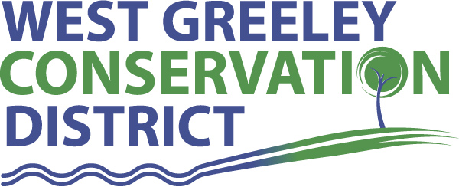
Board of Supervisors
Meeting Agenda

Monday, February 8, 2021

11:00 a.m.
Greeley USDA Service Center
4302 W 9th Street Rd
Greeley, CO 80634

Welcome, roll call, and meeting called to order:
Introduction of Guests:
Approval of Board Meeting Minutes from Regular Meeting January 2021
( ) ( )
Approval of January 2021 Treasurers Report and Financial Statements
( ) ( )
Approval of Accounts Payable for January 2021
( ) ( )
Staff Reports
- Staff
- Liz Schneider, Conservation Technician

- Jasen Kettle, Houston Garden Coordinator

- Kristi Helzer, Community Outreach/Ed Coordinator

- LeRoy D. Hall, Conservation Technician

- Taylor Webb, Office Assistant

Partner Reports
NRCS Report: Sam Adams DC/NRCS

- Referrals: ( ) ( )
- Report:

CSU Extension Report: Larry Hooker ED/CSU Extension

New Business/Request for Financial Support

- Weld County Fair Sponsorship $1,000 ( ) ( )
- Windbreak Cost Share ( ) ( )
- Larson, Greg and Vicki for $3500
- Johnson, Jesse for $3500
- Cost Shares: Klawonn, Glen
- CRP Fencing Recovery $10,000 max ( ) ( )
- Livestock Well $10,000 max ( ) ( )
- Crossroads Insurance Renewal Premium $29,552.00
- Truax Repairs & Replacement Parts
- Menjivar Elm Tree Removal $7000 ( ) ( )
- Roullard Lateral Phase II Cost Share Discussion ( ) ( )
- Employee Reviews at 5% Increase ( ) ( )
- K. Helzer
- J. Kettle
- L. Schneider
- K. Nourse

Unfinished Business

- Growling Bear – Historical Register Outcome on Roof
- Greenhouse Planning on Track
- USDA Service Center Keying/Security System
- Livestock Tank & Pipeline Cost Share Review
- Lawn Watering Cost Share

Weld County Referrals ( ) ( )

- Daniel and Debra Baker SPR21-0001 Site plan for office space, outdoor storage, and vehicle service/repair
- Sean Brooks ZPHO21-0004 Home occupation for firearms service, repair, customization, and transfers
- State of Colorado USR21-0003 Site Specific development plan and special review permit for open mining and processing of materials outside of subdivision and historic townsites in the Ag Zone
- Wilcox Rebecca LLA21-0001 Lot line adjustment

Notice of Filing Application Colorado Mined Land Reclamation Permit (112)
Construction Materials Extraction Operation
- Superior Oilfield Services Co. Ltd

Annexation Notifications:

Concept Plan Application in Severance

BIO SOLID PERMIT
- None
Announcements and Reminders
- Board Members should turn in mileage Reimbursements.
- Office Closed on February 15, 2021 for President’s Day
- Next Meeting is March 8, 2021

Executive Session: Time is set aside to adjourn the open meeting and go into executive session in accordance with (CRS 24-6-402 (4) (f).
1:00 pm Adjournment

Board Members Present Partners Present

( ) John Leone ( ) Sam Adams – NRCS
( ) Randy Miller ( ) Larry Hooker – ED/CSU Weld County Extension
( ) Lenny Simpson ( ) Jeff Rasmussen – CED/FSA USDA Greeley Service Ctr
( ) Tony Becker ( ) Bailey Rapp – Area Conservationist/NRCS
( ) Allen Beloin

Staff Members Present Guests Present

( ) Liz Schneider ( )
( ) Jasen Kettle ( )
( ) Kristi Helzer
( ) Bruce Cameron
( ) Kandee Nourse
( ) Taylor Webb
( ) LeRoy “Roy” Hall
( )

