West Greeley Conservation District
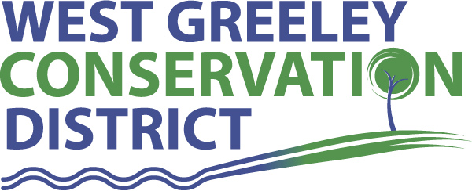
Board of Supervisors
Meeting Agenda

Monday, January 11, 2021

11:00 a.m.
Greeley USDA Service Center
4302 W 9th Street Rd
Greeley, CO 80634

Welcome, roll call, and meeting called to order:
Introduction of Guests:
Approval of Board Meeting Minutes from Regular Meeting December 2020
( ) ( )
Approval of December 2020 Treasurers Report and Financial Statements
( ) ( )
Approval of Accounts Payable for December 2020
( ) ( )
Staff Reports
- Staff
- Liz Schneider, Conservation Technician

- Jasen Kettle, Houston Garden Coordinator

- Kristi Helzer, Community Outreach/Ed Coordinator

- LeRoy D. Hall, Conservation Technician

- Taylor Webb, Office Assistant

Partner Reports
NRCS Report: Sam Adams DC/NRCS

- Referrals: ( ) ( )
- Report:

CSU Extension Report: Larry Hooker ED/CSU Extension

New Business/Request for Financial Support

- Windbreak Cost Share ( ) ( )
- Oliver, Wally & Libby, Eaton CO $3500
- Coalbank Dam Fence Repair – approx. $6500 ( ) ( )
- Lawn Smart Water System Cost Share Ideas
- COLA 1% ( ) ( )
- Supervisor Mileage Rate for 2021 is $.56/mile
- Started Employee Review Process for 2021
- Anderson & Whitney Audit $10,000
- Pipeline and Tank Cost Share Discussion
- WGCD Insurance Company Update
- Scholarship Recipient J. Aldana Flores Update

Unfinished Business

- Growling Bear – Historical Register Paperwork
- Greenhouse Planning on Track
- USDA Service Center Keying/Security System – on track

Weld County Referrals ( ) ( )

- Barton Land and Cattle, Inc USR20-0038 Site Development Plan and use by Special Review for a Commercial Roping Arena in the A Zone
- Duran Enterprises LLC COZ20-0009 Change Zone from the A to the I-2( Medium Industrial) Zone
- Welstett Holdings ZPAG20-0036 A Zoning Permit for Certain Uses in the AG Zone. (Contractor’s shop- indoor parking)
- Zigray Ryan ZPAG20-0035 Zoning Permit for a second Single Family Dwelling, Located in the A Zone.

Notice of Filing Application Colorado Mined Land Reclamation Permit (112)
Construction Materials Extraction Operation

Consideration of Construction Materials Reclamation Permit Amendment Application
- Iverson Mine – File No. M-2011-001, Martin Marietta Materials, Inc
- Raindance Sand and Gravel Mine – M-2004-022, Raindance Aquatic Investments, LLC
Annexation Notifications:

Concept Plan Application in Severance

BIO SOLID PERMIT
- None
Announcements and Reminders
- Board Members should turn in mileage Reimbursements.
- Office Closed – Monday, January 18 for MLK, Jr Day
- Next Meeting is February 8, 2021, USDA Service Center @ 11:00 a.m.

Executive Session: Time is set aside to adjourn the open meeting and go into executive session in accordance with (CRS 24-6-402 (4) (f).
1:00 pm Adjournment

Board Members Present Partners Present

( ) John Leone ( ) Sam Adams – NRCS
( ) Randy Miller ( ) Larry Hooker – ED/CSU Weld County Extension
( ) Lenny Simpson ( ) Jeff Rasmussen – CED/FSA USDA Greeley Service Ctr
( ) Tony Becker ( ) Bailey Rapp – Area Conservationist/NRCS
( ) Allen Beloin

Staff Members Present Guests Present

( ) Liz Schneider ( )
( ) Jasen Kettle ( )
( ) Kristi Helzer
( ) Bruce Cameron
( ) Kandee Nourse
( ) Taylor Webb
( ) LeRoy “Roy” Hall
( )

