West Greeley Conservation District
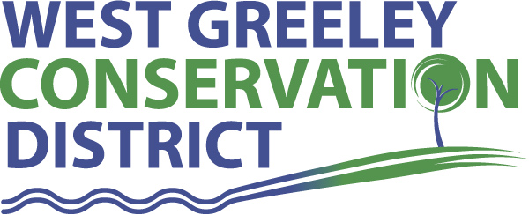
Board of Supervisors
Meeting Agenda

Monday, July 12, 2021

11:00 am
Houston Garden
515 23rd Avenue
Greeley, CO 80634

Welcome, roll call, and meeting called to order:
Introduction of Guests: Alan Holmberg, Anderson & Whitney
Approval of Board Meeting Minutes from Regular Meeting June 2021
( ) ( )
Approval of June 2021 Treasurers Report and Financial Statements
( ) ( )
Approval of Accounts Payable for June 2021
( ) ( )
Staff Reports
- Staff
- Liz Schneider, Conservation Technician

- Jasen Kettle, Houston Garden Coordinator

- Kristi Helzer, Community Outreach/Ed Coordinator

- LeRoy D. Hall, Conservation Technician

- Taylor Webb, Office Assistant

- Bruce Cameron, Conservation Technician

- Ryan Kapperman, Field Technician

Partner Reports
NRCS Report: Will Owsley, Resource Team Leader

- Report:

CSU Extension Report: Larry Hooker ED/CSU Extension

FSA Report: Jeff Rasmussen ED

New Business/Request for Financial Support
- Coalbank Dam Inspection Review and signature
- Colorado Ag in the Classroom Sponsorship $2500 ( ) ( )
- CALP Donation Form
- CSCB/CDA Drought Stimulus Money $15000
- Greeley Lock and Key – new west door operator $3866 ( ) ( )
- Concrete Work at the shop starts July 28/July 29 by FCS
- 2020 Financial Statement Approval - ( ) ( )
- NACD Southwest Regional Meeting in Jackson Hole, WY end of August
- New Equipment for Houston Garden
- Kubota RTV 520H $12,830 is no longer available
- Club Carry All $17,064.60
- Still Obtaining Estimates for gutter replacement on house, garage and nook
- Cost Share CRP Remediation D. Sheller max of $10,000 ( ) ( )

Unfinished Business

- Certificate of Deposit Maturity 08/27/2021
- Update on Pavilion and Payment of $131,171.35 ( ) ( )
- Greenhouse Project Continued Discussion – Nexus to attend at a future meeting
- Symposium/Annual Meeting Update (November 3-4) Double Tree
- Demo Farm Discussion on Pros/Cons and Benefits to District and Constituents

Weld County Referrals ( ) ( )

- Ottenhoff, George and Jennyrae c/o American Tower 1MUSR21-08-1632 Minor Amendment to SSDPandUse
- Meining, Jim ZPAG21-0020 Zoning Permit for Certain Uses in Ag Zone District for a Landscaping Company
- Johnson, John and Dorothy and Johnson Dairy Ag Professionals 4MUSR21 01 1282 Fourth Minor Amendment for Ag Service Establishment
- Duran Enterprises LLC SPR21 0005 Site Plan and Review for mini storage

NRCS CTA Referrals
( ) ( )

NOTICE Consideration of 111 Construction Materials Reclamation Permit Application
- Koenig Pt File 1980 120
- Burnham Property Borrow File No M 2021 019

Annexation Notifications:

Town of Kersey Minor Subdivision Plat
Town of Severance Concept Plan / Neighsayer LLC Ft Collins, CO

BIO SOLID PERMIT
- None
Announcements and Reminders
- Board Members should turn in mileage Reimbursements.
- Next Meeting is August 9, 2021
- BBQ August 13, 2021
- Chamber Ag Tour August 27, 2021

Executive Session: Time is set aside to adjourn the open meeting and go into executive session in accordance with (CRS 24-6-402 (4) (f).
1:00 pm Adjournment

Board Members Present Partners Present

( ) John Leone ( ) Sam Adams – NRCS
( ) Randy Miller ( ) Larry Hooker – ED/CSU Weld County Extension
( ) Lenny Simpson ( ) Jeff Rasmussen – CED/FSA USDA Greeley Service Ctr
( ) Tony Becker ( ) Will Owsley - NRCS
( ) Allen Beloin

Staff Members Present Guests Present

( ) Liz Schneider ( ) Alan Holmberg
( ) Jasen Kettle ( )
( ) Kristi Helzer
( ) Bruce Cameron
( ) Kandee Nourse
( ) Taylor Webb
( ) LeRoy “Roy” Hall
( )

