West Greeley Conservation District
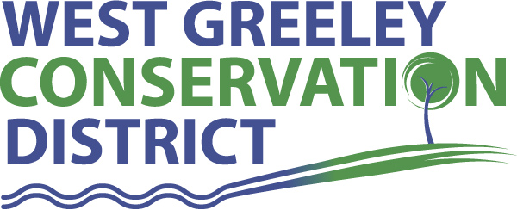
Board of Supervisors
Meeting Agenda

Monday, June 14, 2021

9:00 am Coalbank Dam Inspection
11:00 am
Houston Garden
515 23rd Avenue
Greeley, CO 80634

Welcome, roll call, and meeting called to order:
Introduction of Guests: Tina Booton, WC Weeds Supervisor, Lyndsay Holbrook, Sheridan Wolf, Soil Technician/NRCS, Jesse Key, Student Observer, John Gauthiere, PE, Gauthiere Engineering
Approval of Board Meeting Minutes from Regular Meeting May 2021
( ) ( )
Approval of May 2021 Treasurers Report and Financial Statements
( ) ( )
Approval of Accounts Payable for May 2021
( ) ( )
Staff Reports
- Staff
- Liz Schneider, Conservation Technician

- Jasen Kettle, Houston Garden Coordinator

- Kristi Helzer, Community Outreach/Ed Coordinator

- LeRoy D. Hall, Conservation Technician

- Taylor Webb, Office Assistant

- Bruce Cameron, Conservation Technician

- Ryan Kapperman, Field Technician

Partner Reports
NRCS Report: Will Owsley, Resource Team Leader

- Report:

CSU Extension Report: Larry Hooker ED/CSU Extension

FSA Report: Jeff Rasmussen ED

New Business/Request for Financial Support
- Certificate of Deposit Maturity 08/27/2021
- Colorado Wheat Field Days Field Day Sponsorship $500
- Farming Evolution Sponsorship $1000 in 2022
- New Equipment for Houston Garden
- Grasshopper Mower Model 524V-42PF $7500
- Kubota RTV 520H $12,830
- Obtain Estimates for gutter replacement on house, garage and nook
- Concrete Work at Shop
- FCS bid $18,402.00
- Chamber Ag Tour Sponsorship $2500 ( ) ( )
- Small Grant Request from Union Colony Elementary $ 1810
Outdoor Classroom / Raised Beds
- Sprinkler Efficiency Improvement Cost Share
Bruce McReynolds
- CRP Recovery Cost Share
Brian Hill
- 2020 Audited Financial Statement Review ( ) ( )
- July Meeting Photograph Board and Staff for updated Promo’s
- Prairie Dog Relocation Notification Discussion

Unfinished Business

- Scholarship Recipient Status Change
- Update on Pavilion and Payment of $131,171.35 ( ) ( )
- Greenhouse Project Continued Discussion – Nexus will attend the July meeting
- Symposium Update
- Demo Farm Discussion on Pros/Cons and Benefits to District and Constituents
- White Plumb Farm Site Visit with COG Cultural and Museum Divisions
Weld County Referrals ( ) ( )

NRCS CTA Referrals
( ) ( )

NOTICE Consideration of 111 Construction Materials Reclamation Permit Application
- Raindance Reservoir #2 File No M 2021 020
- Malone Gravel Pit File no M 2021 021
- E 8th Street Operation File No M 2000 082
- Burnham Property Borrow M 2021 031
- Ames Construction
Annexation Notifications:

Town of Kersey Minor Subdivision Plat
Town of Severance Preliminary Plat

BIO SOLID PERMIT
- None
Announcements and Reminders
- Board Members should turn in mileage Reimbursements.
- Next Meeting is July 12, 2021
- BBQ August 13, 2021
- Chamber Ag Tour August 27, 2021
Executive Session: Time is set aside to adjourn the open meeting and go into executive session in accordance with (CRS 24-6-402 (4) (f).
1:00 pm Adjournment

Board Members Present Partners Present

( ) John Leone ( ) Sam Adams – NRCS
( ) Randy Miller ( ) Larry Hooker – ED/CSU Weld County Extension
( ) Lenny Simpson ( ) Jeff Rasmussen – CED/FSA USDA Greeley Service Ctr
( ) Tony Becker ( ) Will Owsley - NRCS
( ) Allen Beloin

Staff Members Present Guests Present

( ) Liz Schneider ( )
( ) Jasen Kettle ( )
( ) Kristi Helzer
( ) Bruce Cameron
( ) Kandee Nourse
( ) Taylor Webb
( ) LeRoy “Roy” Hall
( ) Lauren Wagner

