West Greeley Conservation District
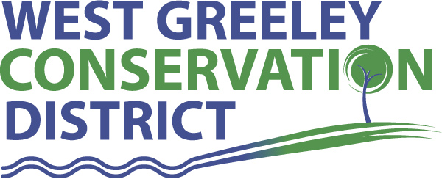
Board of Supervisors
Meeting Agenda

Monday, March 8, 2021

11:00 a.m.
Greeley USDA Service Center
4302 W 9th Street Rd
Greeley, CO 80634

Welcome, roll call, and meeting called to order:
Introduction of Guests:
Approval of Board Meeting Minutes from Regular Meeting February 2021
( ) ( )
Approval of February 2021 Treasurers Report and Financial Statements
( ) ( )
Approval of Accounts Payable for February 2021
( ) ( )
Staff Reports
- Staff
- Liz Schneider, Conservation Technician

- Jasen Kettle, Houston Garden Coordinator

- Kristi Helzer, Community Outreach/Ed Coordinator

- LeRoy D. Hall, Conservation Technician

- Taylor Webb, Office Assistant

- Bruce Cameron, Conservation Technician

Partner Reports
NRCS Report: Sam Adams DC/NRCS

- Referrals: ( ) ( )
- Report:

CSU Extension Report: Larry Hooker ED/CSU Extension

New Business/Request for Financial Support

- Houston Garden: Extend Sprinkler Lines $7150 ( ) ( )
- Houston Garden: Proposal for Electrical Upgrade to Garage $1590 ( ) ( )
- Coalbank Dam Fencing completed at $29,559.25
- Cost Shares: Burnett, Jerry
- CRP Fencing Recovery $10,000 max ( ) ( )
- Livestock Well $10,000 max ( ) ( )
- Cost Share: Bartells Family Trust
- CRP Fencing Recover $10,000 max ( ) ( )
- CACD 2021 Dues $1200 ( ) ( )
- CEBT Dividend $2925 (unrestricted surplus)
- Scholarship Deadline is March 26
- Board Member Availability
- Updated Staffing Guidance

Unfinished Business

- Growling Bear – status quo
- Historical Society Hearing March 1 voted to approve Pavilion request

Weld County Referrals ( ) ( )

- Dustin & Sandra Winter FFD21-0004 Family Farm Division
- Kevin Brittner ZPHB21-0001 Zoning Permit for a Home Business- for a Welding Shop
- Taurino Cabrera and Siamond Land LLC LLA21-0007 Lot Line Adjustment
- Myron & Elizabeth Phinney and Justin & Deborah Phinney LLA21-0006 Lot Line Adjustment between Lot A and Lot B

NOTICE Consideration of Construction Materials Reclamation Permit Amendment Application
- North Star Pit M-2012-004 Superior Oilfield Services Amendment Ap (AM-2)

Annexation Notifications:
- Chaparral Project in Severance
Final Plat:
- The Reserve in Severance

Town of Kersey Public Hearing
- Amended Site Plan and Variance to eliminate any additional landscaping in the Industrial District

BIO SOLID PERMIT
- None
Announcements and Reminders
- Board Members should turn in mileage Reimbursements.
- Scholarship Deadline is March 26, 2021
- Next Meeting is April 12, 2021

Executive Session: Time is set aside to adjourn the open meeting and go into executive session in accordance with (CRS 24-6-402 (4) (f).
1:00 pm Adjournment

Board Members Present Partners Present

( ) John Leone ( ) Sam Adams – NRCS
( ) Randy Miller ( ) Larry Hooker – ED/CSU Weld County Extension
( ) Lenny Simpson ( ) Jeff Rasmussen – CED/FSA USDA Greeley Service Ctr
( ) Tony Becker ( ) Bailey Rapp – Area Conservationist/NRCS
( ) Allen Beloin

Staff Members Present Guests Present

( ) Liz Schneider ( )
( ) Jasen Kettle ( )
( ) Kristi Helzer
( ) Bruce Cameron
( ) Kandee Nourse
( ) Taylor Webb
( ) LeRoy “Roy” Hall
( )

