West Greeley Conservation District
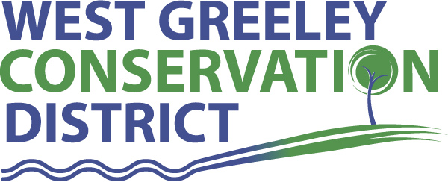
Board of Supervisors
Meeting Agenda

Monday, November 8, 2021

11:00 am
West Greeley Conservation District
4302 W 9th Street Rd
Greeley, CO 80634

Welcome, roll call, and meeting called to order:
Introduction of Guests:
Approval of Board Meeting Minutes from Regular Meeting October 2021
( ) ( )
Approval of October 2021 Treasurers Report and Financial Statements
( ) ( )
Approval of September Payable for October 2021
( ) ( )
Staff Reports
- Staff
- Liz Schneider, Conservation Technician

- Jasen Kettle, Houston Garden Coordinator

- Kristi Helzer, Community Outreach/Ed Coordinator

- LeRoy D. Hall, Conservation Technician

- Taylor Webb, Office Assistant

- Bruce Cameron, Conservation Technician

- Ryan Kapperman, Field Technician

Partner Reports
NRCS Report: Sam Adams and Will Owsley, Resource Team Leaders

- Report:

CSU Extension Report: Hannah Swanbom ED/CSU Extension

FSA Report: None

New Business/Request for Financial Support

- Box Ranch Auction Discussion only
- 2022 Preliminary Budget Review
- Weld County Weeds Division Funds Distribution and Continued Cost Share Interest $___________ ( ) ()
- Electric Heating Restrooms at Houston Garden $1590 () ()
- Weld County Fair Sponsorship $_________ () ()
- Weld County 4-H Foundation Endowment Fund Support
- City of Greeley/Plumb Farm Meeting on Wednesday, November 10

Unfinished Business

- Symposium Review
- Annual Meeting Review
- Greenhouse Project (Prosipiant) on track
- Greeley Fire Department Inspection

Weld County Referrals ( ) ( )

- Robert & Marianna Rohn LLA21-0031 Lot Line Adjustment of SUBX12-0018
- Kammerell Farm LLC c/o PDC Energy ZPTT21-0013 Zoning Permit for Telecommunication Tower on new Battery Lease Area
- Estromina CO Greeley Land LLC USR21-0020 a Site-Specific Development Plan and Use by Special Review Permit for Solar Energy Facility
- Keith Cowan RES21-0009 Resubdivision to Combine 2 Lots into One Lot

NRCS Referrals
( ) ( )

NOTICE Consideration of 111 Construction Materials Reclamation Permit Application

NOTICE Consideration of 112c Construction Materials Reclamation Permit Application
- Loveland Ready Mix / wildlife habitat
- Loloff Mine M-1985-112 Surety Release Request
Annexation Notifications: * None
- Town of Severance
- Town of Severance
- Town of Severance
- Town of Ault

Town of Kersey

Town of Windsor

Town of Johnstown

BIO SOLID PERMIT
- None
Announcements and Reminders
- Board Members should turn in mileage Reimbursements.
- Next Meeting is Monday, December 13 @ the Gourmet Grub

Executive Session: Time is set aside to adjourn the open meeting and go into executive session in accordance with (CRS 24-6-402 (4) (f).
1:00 pm Adjournment

Board Members Present Partners Present

( ) John Leone ( ) Sam Adams – NRCS
( ) Randy Miller ( ) Hannah Swanbom – ED/CSU Weld County Extension
( ) Lenny Simpson
( ) Tony Becker ( ) Will Owsley - NRCS
( ) Allen Beloin

Staff Members Present Guests Present

( ) Liz Schneider ( )
( ) Jasen Kettle ( )
( ) Kristi Helzer
( ) Bruce Cameron
( ) Kandee Nourse
( ) Taylor Webb
( ) LeRoy “Roy” Hall
( ) Ryan Kapperman

