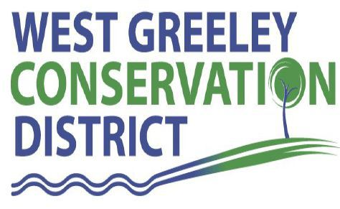
Agreement for Use of Riparian Trailer

I would like to use West Greeley Conservation District’s (WGCD) Riparian Trailer. I understand and agree to the following terms:
I am responsible for safe operation, clean up and transportation of the Riparian Trailer.
I agree to fix or pay for any repairs for damages incurred during my use of the Riparian Trailer.
The trailer will be used at ______________________________________________________
for (number of days) ___________.
I will be picking up the Riparian Trailer on _______________ returning it _______________.
Unless other arrangements are made – there will be a $30.00/day late fee charged.
I understand that I assume full liability for the trailer, contents, and its use, and that I am responsible for returning the trailer to the WGCD/Houston Garden at 515 23rd Avenue, Greeley, CO in a timely manner.
I agree to provide evidence of adequate insurance to cover damages and protect the District and the public during use and transport of the Riparian Trailer as well as a copy of my valid driver’s license.

I certify that I have read and understand the program provisions listed above.

Renter’s printed name _______________________________________________________________________
Renter’s signature __________________________________________ Date_____________
Address __________________________________________________
City, State, Zip Code _________________________________________________________________________
Phone Number ________________________ Email address __________________________________
Insurance Policy #____________________________
Insurance Company Name & Phone #____________________________________________________________
West Greeley Conservation District Representative: Kristi Helzer, 970-356-8097 x: 143

