West Greeley Conservation District
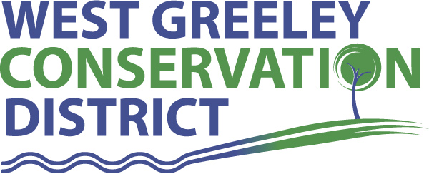
Board of Supervisors
Meeting Agenda

Monday, December 12, 2022

4:00 PM

Gourmet Grub
2118 35th Avenue
Greeley, CO 80634

Welcome, roll call, and meeting called to order:
Introduction of Guests: Alan Holmberg, CPA Anderson & Whitney
Approval of Board Meeting Minutes from Regular Meeting November 2022
( ) ( )
Approval of November 2022 Treasurers Report and Financial Statements
( ) ( )
Approval of Payable for November 2022
( ) ( )
Staff Reports
- Staff
- Liz Schneider, Conservation Technician

- Jasen Kettle, Houston Garden Coordinator

- LeRoy D. Hall, Conservation Technician

- Taylor Webb, Community Engagement Specialist

- Ryan Kapperman, Field Technician

- Bruce Cameron, Seasonal Technician

Partner Reports
NRCS Report: Will Owsley, Resource Team Leader

CSU Extension Report: Hannah Swanbom ED/CSU Extension

New Business/Request for Financial Support
- HSA Limits for 2023 - $3,850 up from $3,650 in 2022
R. Kapperman, J. Kettle, E. Schneider, K. Nourse
- Approval for 2022 Christmas Bonuses as proposed
- Designated Election Official for 2023 (Leone, Becker, Simpson)

Unfinished Business

- 2023 Final Budget Approval
- Gate Expansion at Houston Garden Entrance Update
- Greenhouse Project Update
- Changes in General Contractor and/or Project Manager
- DS Constructors Project Closeout Billing $20,036.87
- 2022 WGCD Ag Symposium Recap and Evaluation Responses
- DNA Concrete work completed

Weld County Referrals ( ) ( )

- BEARS INVESTMENTS LLC & LTD LLC Case Number: LLA22-0040
Project: LOT LINE ADJUSMENT BETWEEN LOT D OF RECX15-0135 AND LOT B OF RECX17-0119

- Christopher Gleason Case Number: USR22-0033 Project: A Site Specific Development Plan and Use by Special Review Permit for a Breeding and Boarding Kennel

- HS LAND & CATTLE LLC Case Number: USR22-0030
c/o MONARCH MOUNTAIN MINERALS AND AGGREGATES
Project: Site Specific Development Plan and Use by Special Review for open mining
Sand, gravel, stone, and overburden) and processing of minerals
- George L. Sandberg Irrevocable Trust Case Number: COZ22-0014 Change of Zone from the A (Agricultural) Zone District to the I-2 (Medium Industrial) Zone District.

- TANNER MOSER Case Number: ZPHB22-0006 Zoning Permit for a Class II Home Occupation - Beauty Salon

NRCS Referrals
( ) ( )

NOTICE Consideration of 111 Reclamation Permit Application

- IHC Scott conduct the extraction of construction materials

Annexation Notifications:
- Town of Severance: NONE
- Town of Milliken: NONE
- Town of Ault: NONE

PUBLIC HEARING
- Town of Kersey
- Variance Section 17 (future re-development)
- Referral Request Site Plan Review Building Architecture Update ChampionX LLC, Oilfield support services

BIO SOLID PERMIT: None

REMINDERS
- Board Members should turn in mileage Reimbursements.
- Next Meeting is Monday, January 9, 2023, WGCD 4302 W 9th Street Rd, Greeley, CO 11:00 am
- Upcoming Holiday/Office Closures: December 23 – December 26; January 2, 2023; January 16, 2023

Executive Session: Time is set aside to adjourn the open meeting and go into executive session in accordance with (CRS 24-6-402 (4) (f).
1:00 pm Adjournment

Board Members Present Partners Present

( ) John Leone ( ) Will Owsley - NRCS
( ) Lenny Simpson ( ) Hannah Swanbom
( ) Tony Becker ( )
( ) Allen Beloin
( ) Dale Souther

Staff Members Present Guests Present

( ) Jasen Kettle ( )
( ) Kandee Nourse
( ) LeRoy Hall
( ) Liz Schneider
( ) Ryan Kapperman
( ) Taylor Webb

