West Greeley Conservation District
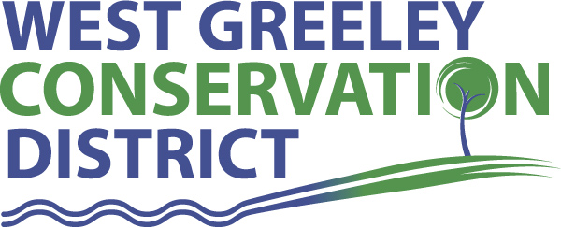
Board of Supervisors
Meeting Agenda

Monday, February 14, 2022

11:00 a.m.

West Greeley Conservation District
4302 W 9th Street Rd
Greeley, CO 80634

Welcome, roll call, and meeting called to order:
Introduction of Guests:
Approval of Board Meeting Minutes from Regular Meeting January 2022
( ) ( )
Approval of January 2022 Treasurers Report and Financial Statements
( ) ( )
Approval of Payable for January 2022
( ) ( )
Staff Reports
- Staff
- Liz Schneider, Conservation Technician

- Jasen Kettle, Houston Garden Coordinator

- Kristi Helzer, Community Outreach/Ed Coordinator

- LeRoy D. Hall, Conservation Technician

- Taylor Webb, Office Assistant

- Bruce Cameron, Conservation Technician

- Ryan Kapperman, Field Technician

Partner Reports
NRCS Report: Will Owsley, Resource Team Leader

- Report:

CSU Extension Report: Hannah Swanbom ED/CSU Extension

FSA Report: Hallie Barlow, CED

New Business/Request for Financial Support

- Windbreak Cost Share - $
- x
- Cancellation of Election ( ) ( )
- Reclamation Restoration Project

Unfinished Business

- F350 Accident CR47 & Hwy 392 – Update and estimates
- Greenhouse Meeting : Feb 18 @ 10:30

Weld County Referrals ( ) ( )

- x

NRCS Referrals
( ) ( )

NOTICE Consideration of 112c Construction Materials Reclamation Permit Application
- Red Tierra Equities LLC, Section 20 Gravel Mine, File No M-2022-001
- Monarch Mountain Minerals and Aggregates, LLC

NOTICE Consideration of Construction Materials Reclamation Permit Surety Reduction Request Application
- Journey Ventures Pit – File No. M-2008-080

Annexation Notifications: * None
- Town of Severance
- Town of Severance
- Town of Severance
- Town of Ault

Town of Kersey

Town of Windsor

Town of Johnstown

BIO SOLID PERMIT
- None
Announcements and Reminders
- Board Members should turn in mileage Reimbursements.
- Next Meeting is Monday, April 11, 2022

Executive Session: Time is set aside to adjourn the open meeting and go into executive session in accordance with (CRS 24-6-402 (4) (f).
5:00 pm Adjournment

Board Members Present Partners Present

( ) John Leone ( ) Will Owsley - NRCS
( ) Randy Miller ( ) Hannah Swanbom – ED/CSU Weld County Extension
( ) Lenny Simpson ( ) Hallie Barlow – CED/FSA
( ) Tony Becker ( )
( ) Allen Beloin

Staff Members Present Guests Present

( ) Liz Schneider ( )
( ) Jasen Kettle ( )
( ) Kristi Helzer
( ) Bruce Cameron
( ) Kandee Nourse
( ) Taylor Webb
( ) LeRoy “Roy” Hall
( ) Ryan Kapperman

