West Greeley Conservation District
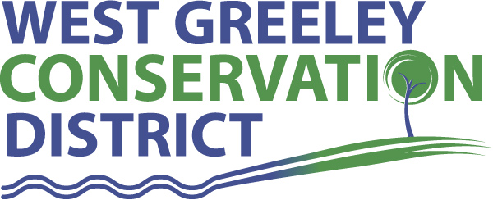
Board of Supervisors
Meeting Agenda

Monday, January 10, 2022

11:00 a.m.

West Greeley Conservation District
4302 W 9th Street Rd
Greeley, CO 80634

Welcome, roll call, and meeting called to order:
Introduction of Guests:
Approval of Board Meeting Minutes from Regular Meeting December 2021
( ) ( )
Approval of December 2021 Treasurers Report and Financial Statements
( ) ( )
Approval of Payable for December 2021
( ) ( )
Staff Reports
- Staff
- Liz Schneider, Conservation Technician

- Jasen Kettle, Houston Garden Coordinator

- Kristi Helzer, Community Outreach/Ed Coordinator

- LeRoy D. Hall, Conservation Technician

- Taylor Webb, Office Assistant

- Bruce Cameron, Conservation Technician

- Ryan Kapperman, Field Technician

Partner Reports
NRCS Report: Sam Adams and Will Owsley, Resource Team Leaders

- Report:

CSU Extension Report: Hannah Swanbom ED/CSU Extension

FSA Report: Hallie Barlow, CED

New Business/Request for Financial Support

- 2022 HSA Limit $3650 there are six employees to be considered for the HSA consideration. ( ) ( )
- 2022 COLA 2.98% ( ) ( )
- Upcoming 2021 Audit starting in January
- New Copier $7,000 ( ) ( )
- Small Grant Request $1500 – Heidi Lanning / Eaton Ag Instructor
- Windbreak Cost Share $3500 – Kindvall, Larry ( ) ( )
- Employee Review Approval ( ) ( )
- New Cost Share Discussion – Youth Land Lease
- Colorado Farm Show – January 25-27

Unfinished Business

- F350 Accident CR47 & Hwy 392 – Update and estimates
- Samber, Rocky Cost Share discussion – no return call from State Land Board

Weld County Referrals ( ) ( )

- .Kevin Smith & Timothy & Cynthia Smith FFD21-0033 Family Farm Division on Two Parcels each with a set of Improvements.

NRCS Referrals
( ) ( )

NOTICE Consideration of Construction Materials Reclamation Permit Application
- Fiscus North – File M2007038

NOTICE Consideration of 112c Construction Materials Reclamation Permit Application
- Stiles Mining Resource File M2021067
- Red Tierra Equities, Gilcrest

NOTICE - Public Hearing
- Town of Kersey Site Plan Review to construct a Dollar Tree

Annexation Notifications: * None
- Town of Severance: Project Intent- Severance Storage
- Town of Severance
- Town of Severance
- Town of Ault

Town of Kersey

Town of Windsor

Town of Johnstown

BIO SOLID PERMIT
- None
Announcements and Reminders
- Board Members should turn in mileage Reimbursements.
- Next Meeting is Monday, February 14, 2022 at the WGCD office

Executive Session: Time is set aside to adjourn the open meeting and go into executive session in accordance with (CRS 24-6-402 (4) (f).
5:00 pm Adjournment

Board Members Present Partners Present

( ) John Leone ( ) Sam Adams – NRCS
( ) Randy Miller ( ) Hannah Swanbom – ED/CSU Weld County Extension
( ) Lenny Simpson ( ) Hallie Barlow – CED/FSA
( ) Tony Becker ( ) Will Owsley - NRCS
( ) Allen Beloin

Staff Members Present Guests Present

( ) Liz Schneider ( )
( ) Jasen Kettle ( )
( ) Kristi Helzer
( ) Bruce Cameron
( ) Kandee Nourse
( ) Taylor Webb
( ) LeRoy “Roy” Hall
( ) Ryan Kapperman

