West Greeley Conservation District
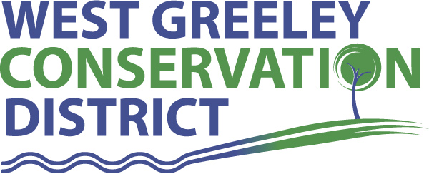
Board of Supervisors
Meeting Agenda

Monday, July 11, 2022

11:00 a.m.

Houston Garden
515 23rd Ave
Greeley, CO 80634

Welcome, roll call, and meeting called to order:
Introduction of Guests:
Alan Holmberg, CPA/Anderson & Whitney
Approval of Board Meeting Minutes from Regular Meeting June 2022
( ) ( )
Approval of June 2022 Treasurers Report and Financial Statements
( ) ( )
Approval of Payable for June 2022
( ) ( )
Staff Reports
- Staff
- Liz Schneider, Conservation Technician

- Jasen Kettle, Houston Garden Coordinator

- LeRoy D. Hall, Conservation Technician

- Taylor Webb, Community Engagement Specialist

- Bruce Cameron, Conservation Technician

- Ryan Kapperman, Field Technician

Partner Reports
NRCS Report: Will Owsley, Resource Team Leader

CSU Extension Report: Hannah Swanbom ED/CSU Extension

FSA Report: Hallie Barlow, CED

New Business/Request for Financial Support
- Approval for 2021 Audited Financial Reports ( ) ( )
- Greeley Chamber Ag Tour - $2500 ( ) ( )
- Theft at Houston Garden
- Coalbank Dam Inspection Report / Sign off ( ) ( )
- 2022 Pawnee Buttes Seed Grass Tour
- House Joint Resolution 22-1018 – Col. Stan Cass Memorial Highway
Donation to the fund ( ) ( )
- Petition Into District
Velasco, Joel & Sadie 16955 CR 33, Platteville, CO 80651
Velasco, Joel & Sadie 15784 CR 36, Platteville, CO 80651

Unfinished Business

- Greenhouse Project – Recap Meeting June 28
- City of Greeley, Culture, Park and Recreation – Agricultural Heritage Center at Centennial Village Museum - Financial Support Discussion
- Ongoing Planning for the BBQ – August 12 (parking solutions)

Weld County Referrals ( ) ( )

- Casey & Lisa Elder and Darryl & Sue Woods LLA22-0028 LLA between Lot B RE-749 and Lot B RE-1371
- Jason & Amy Wood ZPHB22-0004 Zoning Permit for home Occupation Class Permit
- Rodney & Karen Steely LLA22-0024 Lot Line Adjustment between lot A and B of RE-3779
- Ronnie Grinstead & Kimberlee Gabel(Lot B) J Robert Sherwood(Lot A) Lot Line Adjustment between Lot A and B of Recorded Exemption RE-3937
- Janssen Farms, LLC c/o SunShare LLC d/b/a Grizzly Solar LLC ZPSF22-0004 Zoning Permit for Solar Energy Facility in the A Zone
- Basiliere Wesley Jay PUDF22-0003 A PUD Final Plan 2 residential Lots with Estate Zones uses. Single family home per lot and the allowed animal units per lot.
- Adam’s Apple, Inc. USR22-0016 Site Specific Development Plan for an Event Facility.

NRCS Referrals
( ) ( )

NOTICE Consideration of 112c Construction Materials Reclamation Permit Application

LAND USE APPROVAL NOTIFICATION

Annexation Notifications:
- Town of Severance
- Town of Severance
- Town of Ault

Town of LaSalle:

Town of Windsor

Town of Johnstown

BIO SOLID PERMIT

- Board Members should turn in mileage Reimbursements.
- Next Meeting is Monday, August 8, 2022
- BBQ is August 12, 2022

Executive Session: Time is set aside to adjourn the open meeting and go into executive session in accordance with (CRS 24-6-402 (4) (f).
1:00 pm Adjournment

Board Members Present Partners Present

( ) John Leone ( ) Will Owsley - NRCS
( ) Randy Miller ( ) Hannah Swanbom
( ) Lenny Simpson ( ) Hallie Barlow
( ) Tony Becker ( )
( ) Allen Beloin

Staff Members Present Guests Present

( ) Liz Schneider ( ) Alan Holmberg
( ) Jasen Kettle ( )
( ) Bruce Cameron
( ) Kandee Nourse
( ) Taylor Webb
( ) LeRoy “Roy” Hall
( ) Ryan Kapperman

