West Greeley Conservation District
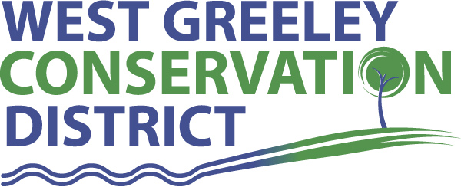
Board of Supervisors
Meeting Agenda

Monday, June 13, 2022

Coalbank Dam Inspection at 9:00 a.m.

11:00 a.m.
at
Houston Garden
515 23rd Ave
Greeley, CO 80634

Welcome, roll call, and meeting called to order:
Introduction of Guests:
Kat Caswell, Agronomist, CSU/Weld County Extension
Approval of Board Meeting Minutes from Regular Meeting May 2022
( ) ( )
Approval of May 2022 Treasurers Report and Financial Statements
( ) ( )
Approval of Payable for May 2022
( ) ( )
Staff Reports
- Staff
- Liz Schneider, Conservation Technician

- Jasen Kettle, Houston Garden Coordinator

- LeRoy D. Hall, Conservation Technician

- Taylor Webb, Community Engagement Specialist

- Bruce Cameron, Conservation Technician

- Ryan Kapperman, Field Technician

Partner Reports
NRCS Report: Will Owsley, Resource Team Leader

CSU Extension Report: Hannah Swanbom ED/CSU Extension

FSA Report: Hallie Barlow, CED

New Business/Request for Financial Support
- Farmers Bank CD 1200763430 Matures 8/27/2022 (2.95%)
- Petition for the Additions of Lands into WGCD
- Lorene B. Anderson, Galeton, CO
( ) ( )
- Civil Rights Responsibilities for Partners Checklist
- Ranching for Profit Workshop – partnership/sponsorship with BCOR
- Letter of Support - NRCS Watershed PL566 project
( ) ( )
- New Shed for WGCD at the office
- Juneteenth Day – office closed June 20 in observance
- Ongoing Planning for the BBQ – August 12
- Menjivar Tree Removal - $5000 ( ) ( )
Unfinished Business

- Greenhouse Project – No recent updates
- City of Greeley, Culture, Park and Recreation – Agricultural Heritage Center at Centennial Village Museum - Financial Support Discussion

Weld County Referrals ( ) ( )

- Tanager Investments LLC ZPHO22-0002 Zoning permit for home occupation Class I ( gunsmithing, firearm sales and handcrafted outdoorsman goods)
East of and adjacent to CR 39; approximately .22 miles north of CR 72
- SPABS LLC ZPTT22-0005 ZPTT for a fifty foot in height broadband monopole tower constructed in 2008 and permitted in 2021
East of and adjacent to CR 13 and approx. 770’ south of CR 92
- Keith Cowan COZ22-0005 Change of Zone from R-1 (low density residential) zone district to the C-3 (Business commercial) zone district
North of and adjacent to CR 86; west of and adjacent to CR 37

- Rachel Fusco and Connestoga Farm Ground LLC LLA22-0021
Lot line adjustment to modify lot lines of lot A and B of RE1458-and SE-442 lot
North of and adjacent to CR 86; west of and adjacent to CR 37

NRCS Referrals
( ) ( )

NOTICE Consideration of 112c Construction Materials Reclamation Permit Application

LAND USE APPROVAL NOTIFICATION

Annexation Notifications:
- Town of Severance
- Town of Severance
- Town of Ault

Town of LaSalle: Site Plan
- Calven Goza
2.74 acres NW ¼ of S31; T5N; R65W
Ag land to Shop/associated storage
Currently in the annexation process

Town of Windsor
- Trevenna Metropolitan District

Town of Johnstown

BIO SOLID PERMIT

- Board Members should turn in mileage Reimbursements.
- Office Closed Monday, June 20, 2022 – Juneteenth Day
- Next Meeting is Monday, July 11, 2022
- BBQ is August 12, 2022

Executive Session: Time is set aside to adjourn the open meeting and go into executive session in accordance with (CRS 24-6-402 (4) (f).
1:00 pm Adjournment

Board Members Present Partners Present

( ) John Leone ( ) Will Owsley - NRCS
( ) Randy Miller ( ) Hannah Swanbom
( ) Lenny Simpson ( ) Kat Caswell
( ) Tony Becker ( ) Tina Booton
( ) Allen Beloin

Staff Members Present Guests Present

( ) Liz Schneider ( )
( ) Jasen Kettle ( )
( ) Bruce Cameron
( ) Kandee Nourse
( ) Taylor Webb
( ) LeRoy “Roy” Hall
( ) Ryan Kapperman

