West Greeley Conservation District
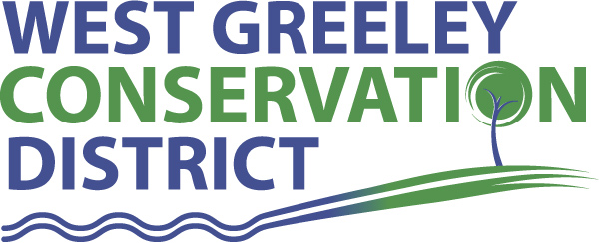
Board of Supervisors
Meeting Agenda

Monday, May 9, 2022

11:00 a.m.

West Greeley Conservation District
4302 W 9th Street Rd
Greeley, CO 80634

Welcome, roll call, and meeting called to order:
Introduction of Guests:
Sarah Saxe, COG, Museums Manager
Approval of Board Meeting Minutes from Regular Meeting April 2022
( ) ( )
Approval of April 2022 Treasurers Report and Financial Statements
( ) ( )
Approval of Payable for April 2022
( ) ( )
Staff Reports
- Staff
- Liz Schneider, Conservation Technician

- Jasen Kettle, Houston Garden Coordinator

- LeRoy D. Hall, Conservation Technician

- Taylor Webb, Community Engagement Specialist

- Bruce Cameron, Conservation Technician

- Ryan Kapperman, Field Technician

Partner Reports
NRCS Report: Will Owsley, Resource Team Leader

CSU Extension Report: Hannah Swanbom ED/CSU Extension

- Not present

FSA Report: Hallie Barlow, CED

New Business/Request for Financial Support
- Sarah Saxe from City of Greeley Culture, Park and Recreation | Museums
- Small Grant Application: $3296 ( ) ( )
Brooke Larson, CASE Principles of Animal Science Training
- Windbreak Cost Share: 50% up to $6000 ( ) ( )
Elizabeth Pfannebecker
- Oath of Office for Randy Miller and Allen Beloin
- CSU Extension Colorado Wheat Field Days Support $ 500
( ) ( )
- Faith Bible Baptist Church – Petition out to consolidate parcels
( ) ( )
6.

Unfinished Business

- Greenhouse Proposed Estimate $448,087 Contract has been signed
- Current payment due for $80,905 has been made
- Tree Sale Update – Pick up dates are May 11-13 (9:00-4:30)

Weld County Referrals ( ) ( )

- Sharon Scheller LLA22-0017 Lot Line Adjustment
- Robert and Kathryn Patterson ZPAG22-0004 Zoning Permit for Ag Zone
- Michael and Heidi Geesen LLA22-0013 LLA between 2 Adjoining parcels
- Galeton Water & Sanitation District 1MUSR22-90-917 Minor Amendment to USR-917 for the Modernization of Galeton Waste Water Plant
- David and Mary Droegemueller LLA22-0018 Lot Line Adjustment Between Lot A and B RE-2497
- David Cogburn c/o US Solar USR22-0013 Site Specific Development and Use by Special Review for a Solar Energy Facility
- Central Weld County Water District PFD22-0001 Public Facility Division in Conjunction with LLA22-0020
- Christopher & Elizabeth Meyette LLA22-0020 Lot Line Adjustment in Conjunction w/ PFD22-0001

NRCS Referrals
( ) ( )

NOTICE Consideration of 112c Construction Materials Reclamation Permit Application
- Two Rivers Sand, Gravel and Reservoir Project, File No. M-2022-013
- Varra Companies extraction - minor corrections

LAND USE APPROVAL NOTIFICATION
- City of Evans - 22-ANNEX01 Hunt Brothers Properties

Annexation Notifications:
- Town of Severance
- Town of Severance
- Town of Severance
- Town of Ault

Town of Kersey

Town of Windsor

Town of Johnstown

BIO SOLID PERMIT

- Board Members should turn in mileage Reimbursements.
- Next Meeting is Monday, May 9, 2022
- Tree Sale Prep and Pick up is May 9-13

Executive Session: Time is set aside to adjourn the open meeting and go into executive session in accordance with (CRS 24-6-402 (4) (f).
5:00 pm Adjournment

Board Members Present Partners Present

( ) John Leone ( ) Will Owsley - NRCS
( ) Randy Miller ( )
( ) Lenny Simpson ( )
( ) Tony Becker ( )
( ) Allen Beloin

Staff Members Present Guests Present

( ) Liz Schneider ( ) Sara Saxe, COG Museums Manager
( ) Jasen Kettle ( )
( ) Kristi Helzer
( ) Bruce Cameron
( ) Kandee Nourse
( ) Taylor Webb
( ) LeRoy “Roy” Hall
( ) Ryan Kapperman

