West Greeley Conservation District
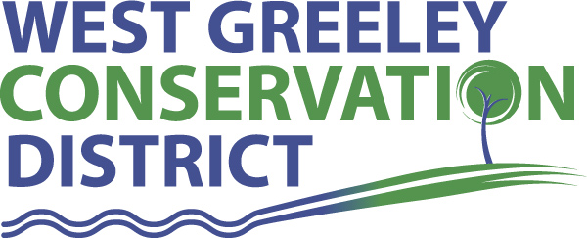
Board of Supervisors
Meeting Agenda

Monday 14, 2022

11:00 a.m.

USDA Service Center
4302 W 9th Street Rd
Greeley, CO 80634

Welcome, roll call, and meeting called to order:
Introduction of Guests:
Approval of Board Meeting Minutes from Regular Meeting October 2022
( ) ( )
Approval of October 2022 Treasurers Report and Financial Statements
( ) ( )
Approval of Payable for October 2022
( ) ( )
Staff Reports
- Staff
- Liz Schneider, Conservation Technician

- Jasen Kettle, Houston Garden Coordinator

- LeRoy D. Hall, Conservation Technician

- Taylor Webb, Community Engagement Specialist

- Ryan Kapperman, Field Technician

Partner Reports
NRCS Report: Will Owsley, Resource Team Leader

CSU Extension Report: Hannah Swanbom ED/CSU Extension

New Business/Request for Financial Support
- Windbreak Cost Share:
- Klinginsmith, Dave and Beth $6000
- NACD 2023 Dues Gold Level $775
- FAMLI Leave Program – December 31, 2022, Deadline
- CACD
- Camp Rocky Discussion
- Resolution to increase dues to $1500
- Menjivar Tree Removal $6500
- Discussion for appointing a Vice President

Unfinished Business

- 2023 Proposed Budget – final approval December 12, 2022
- Gate Expansion at Houston Garden Entrance $19,343 Update
- Greenhouse Project Update
- Historic Preservation Design Review Approval Historical Preservation Hearing
- Meeting with DS Constructors ( $533,916 )
- 73rd Annual Meeting Recap
- Hoffman/Brethauer Dust Blowing Work Session on Wednesday, November 16 @ 3pm
Weld County Referrals ( ) ( )

- Knipple, Rory & Desirea ZPAG22-0014 Zoning Permit for certain uses in the Ag. Specifically, a Contactor Shop.
- Kaycee and Megan Lytle FFD22-0020 Family Farm Division of 88 Acre Parcel
- Aric De Jager FFD22-0022 Family Farm Division
- Sunset Industrial, LLC COZ22-0012 Change from Zone A and I-3 to the I-3 (heavy industry) Zone
- D-Dart Ranch INC FFD22-0021 Family Farm Division

NRCS Referrals
( ) ( )

NOTICE Consideration of 112c Construction Materials Reclamation Permit Application

- Windsor East Mine M2022042

Consideration of Construction Materials Reclamation Permit Surety Reduction Request Application

Annexation Notifications:
- Town of Severance: 2022 BHS Solar Annexation and Zoning
- Town of Milliken:
- Town of Ault:

SERVICE PLAN PUBLIC HEARING

BIO SOLID PERMIT: None

REMINDERS
- Board Members should turn in mileage Reimbursements.
- Next Meeting is Monday, December 12, 2022 @ Gourmet Grub 4PM

Executive Session: Time is set aside to adjourn the open meeting and go into executive session in accordance with (CRS 24-6-402 (4) (f).
1:00 pm Adjournment

Board Members Present Partners Present

( ) John Leone ( ) Will Owsley - NRCS
( ) Lenny Simpson ( ) Hannah Swanbom
( ) Tony Becker ( )
( ) Allen Beloin
( ) Dale Souther

Staff Members Present Guests Present

( ) Jasen Kettle ( )
( ) Kandee Nourse
( ) LeRoy Hall
( ) Liz Schneider
( ) Ryan Kapperman
( ) Taylor Webb

