West Greeley Conservation District
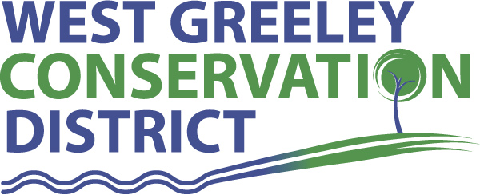
Board of Supervisors
Meeting Agenda

Monday, September 12, 2022

11:00 a.m.

Houston Garden
515 23rd Ave
Greeley, CO 80634

Welcome, roll call, and meeting called to order:
Introduction of Guests: Dale Souther
Approval of Board Meeting Minutes from Regular Meeting August 2022
( ) ( )
Approval of August 2022 Treasurers Report and Financial Statements
( ) ( )
Approval of Payable for August 2022
( ) ( )
Staff Reports
- Staff
- Liz Schneider, Conservation Technician

- Jasen Kettle, Houston Garden Coordinator

- LeRoy D. Hall, Conservation Technician

- Taylor Webb, Community Engagement Specialist

- Ryan Kapperman, Field Technician

- Bruce Cameron, Field Technician

Partner Reports
NRCS Report: Will Owsley, Resource Team Leader

CSU Extension Report: Hannah Swanbom ED/CSU Extension

FSA Report: Hallie Barlow, CED

New Business/Request for Financial Support
- Resignation of Board Member, Randy Miller
- Appointment of Dale Southern to the WGCD Board of Supervisors
- Cost Share Considerations
- Livestock Well (Scott Salo) 50% up to $10,000
- Cover Crop Cost Share (Kaycee Lytle)
- Expiring CRP Fencing Repair (Boyd Collins) 50% up to $10,000
- Certification of Valuation for 2023 Budget
- Northeast Regional Rangeland Contest Sponsorship ($1000) September 29th, 2022 at Prairie School, New Raymer
- CSCB Direct Assistance Allocation is $6,743.41
- Reusable Shopping Bags
- Universal Operator Push/Pull Door (West access) $4895.14

Unfinished Business

- Gate Expansion at Houston Garden Entrance
- Parking Lot Repairs & Striping ($12754) T Case Construction
- House Joint Resolution 22-1018 – Col. Stan Cass Memorial Highway – Donation in his honor $1370 contact CDOT
- Greenhouse Project Update
- Community BBQ – Recap
- New CD’s
- Storage Shed Update

Weld County Referrals ( ) ( )

- James R & Dawn Pennington LLA22-0033 Lot Line Adjustment
- Marvin and Mildred Bay Living Trust LLA22-0034 Lot Line Adjustment
- Pierce Hardy Limited Partnership USR22-0020 Special Review for Lumber yard and transloading facility
- Arthur M Griffiths c/o CBEP Solar LLC USR22-0022 Special review and permit for Solar Energy Facility
- Griffiths Solar #2 USR22-0025 Special Review Permit for Solar Energy Facility

NRCS Referrals
( ) ( )

NOTICE Consideration of 112c Construction Materials Reclamation Permit Application

- VIP Mine File No M-2022-032 Varra Buildings, Inc T9n R66 06th Meridian Weld County

Annexation Notifications:
- Town of Severance:
- Town of Milliken:
- Town of Ault

SERVICE PLAN PUBLIC HEARING
- East of Ash Avenue 128.25 acres South of the Poudre River, north of east 16th Street, and west of Fern Ave
- PUD 817 acres South of Highwa 34, East of CR 17 and West of State Hwy 257
- Two River Market Place 28.941 acres zone Commercial High Intensity South of Bus Hwy 34 North of 12th Street, East of 86th Ave and West of 83rd Ave
- Service Plan Amendment Windsor, CO

BIO SOLID PERMIT: None

REMINDERS
- Board Members should turn in mileage Reimbursements.
- Next Meeting is Tuesday, October 11, 2022
- Columbus Day Monday, October 10, 2022 OFFICE CLOSED

Executive Session: Time is set aside to adjourn the open meeting and go into executive session in accordance with (CRS 24-6-402 (4) (f).
1:00 pm Adjournment

Board Members Present Partners Present

( ) John Leone ( ) Will Owsley - NRCS
( ) Randy Miller ( ) Hannah Swanbom
( ) Lenny Simpson ( ) Hallie Barlow
( ) Tony Becker ( )
( ) Allen Beloin
( ) Dale Souther

Staff Members Present Guests Present

( ) Liz Schneider ( )
( ) Jasen Kettle ( )
( ) Bruce Cameron
( ) Kandee Nourse
( ) Taylor Webb
( ) LeRoy “Roy” Hall
( ) Ryan Kapperman

