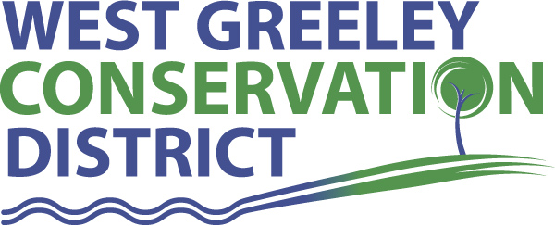
CRP Recovery Cost Share Program
Provisions and Applicant Certification Updated 4/10/23
I would like to participate in West Greeley Conservation District’s (WGCD) CRP Recovery Cost Share Program which is designed to provide support for livestock well drilling, piping and stock tanks, exterior fencing, and interior cross-fencing on expiring CRP land. I understand and agree to the following terms:
- This program is designed specifically to keep expiring CRP land in a grazing situation. Therefore if the applicant has utilized another cost share well drilling program with the District in the past, they may be eligible for an additional cost share well through this program on designated expiring CRP land.
- Limit 1 cost share approval per category, per property, per 10-year period. (For repeat customers, the ten-year period begins after you receive payment from WGCD for previous cost share.)
- All wells and exterior fencing to be cost-shared must currently be on land within the WGCD.

- All wells and exterior fencing to be cost shared must be approved by the WGCD, and be installed in accordance with the Natural Resources Conservation Service’s (NRCS) standards and specifications, and be accompanied by an approved grazing management plan that enhances conservation needs of the land and/or district.

- Cost-Share contract must be signed and returned to WGCD prior to any work being done.

- Landowners are responsible for obtaining their own State permits prior to construction. Landowners are also responsible for submitting a Well Test and Construction Report along with itemized bills once construction is complete.

- No representation is made by WGCD as to the existence or non existence of underground hazards. Landowners are responsible for location of underground utilities, and supplying WGCD personnel with the UNCC reference number for the project, at least 2 days prior to construction. Utilities participating in Utility Notification Center of Colorado (UNCC) can be notified at 1-800-922-1987.

- The minimum number of acres supported by CRP cost share is 140 acres.

- The district will cost share 50% (not to exceed the USDA’s Weld County cost docket per foot) of the cost of the livestock well, and 50% (not to exceed the USDA’s Weld County cost docket per foot) for exterior fencing, for a maximum of $10,000 per fence and $10,000 per well per expiring CRP contract. Any additional costs will be the sole responsibility of the landowner.
- The wells drilled may be used for livestock use only, and not include grazing of horses or home well use, for a period of five years after installation. Thereafter, the well may be used for other purposes as well as livestock water. If the well is used for any purpose other than specified above, within the five years after the completion of the project, the cost share amount must be repaid to the District.

- Applicants are encouraged to install solar electric pumps on new cost share wells.

- Applicants who install fencing may install either permanent high tensile wire electrical fences or permanent 3 wire fences, as per NRCS permanent fencing standards.

- CRP contract must expire within one year of application and project will be in place in accordance to the land use and contract rules of the CRP contract.

- The landowner will be paid after the well and fencing has been installed and inspected by the District, and landowner submits a copy of SSN or Tax ID and an itemized bill(s).

- Program cost share will not exceed 100% of well drilling and casing cost, as well as exterior fence installation, when used in combination of other programs or insurance payments.

- If there is a transfer of ownership of the property through sale, barter, lease or trade prior to the five year rule agreement of this contract, the new owners and/or land users must abide by the five year rule of use or repay the total amount paid out by this cost share agreement to the District.

- Contracts are for land in CRP which will expire 2009 or after.

Cost-Share Application

Applicant name:______________________________________________ Date of Application: ___________

Address:______________________________________________________________

Phone:_________________________________________ Email: _____________________________________

SSN:________________________________________________
Resource concern you are addressing:

Cost share practice applying for: ____________________________________________________

Requested Cost share amount: _______________________

Total Project Cost: _______________________

Project summary and technician notes: (attach plans, maps or technical design if required):

I certify that I have read and understand the program provisions listed on the previous page.

Applicant Signature __________________________________________ Date: ___________

WGCD personnel____________________________________ Date______________
FOR OFFICE USE ONLY-Initial/date

____________ DM Approval

____________ Project Certified

____________ Received Receipts

____________ Payment reimbursed

*Completed applications are reviewed the second Monday of each month.

