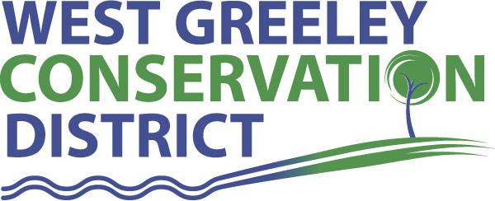
Cover Crop Cost Share – Updated 4/10/20232
The goal of this cost share is to provide financial assistance to landowners who are willing to try new practices on their land - such as cover crops. We hope that landowners can find new conservation methods that work on their property. This is for landowners that are within the West Greeley Conservation District. All participants must be active tax payers of the West District Conservation District.
What is a cover crop? A cover crop is a crop grown for the protection and enrichment of the soil. This is done by managing erosion, disease, weeds, and pests with the selection of the cover crop mix and on farm specific needs. Cover crops enrich the soil by improving fertility, quality, biodiversity and wildlife (micro and macro), enrichment of the soil is also controlled by cover crop mixture selection.
Requirements for cover crop cost share:
- The land must be within the WGCD.
- Limit 1 cost share approval per category, per property, per 10-year period. (For repeat customers, the ten-year period begins after you receive payment from WGCD for previous cost share.)
- The Cost Share form must be completed and returned to WGCD. The form will be taken to the Board of Supervisors for discussion and approval. Quotes for desired work must be submitted with Cost Share form and submitted to WGCD.
- All projects must be approved by WGCD Board of Supervisors prior to seed purchase. If you purchase and plant prior to approval you will be disqualified from Cost Share.
- Acreage requirement is as follows: 0 to 500 acres per landowner per year. This application is for a 5-year commitment of planting cover crops on the chosen field (landowners’ decision) to ensure that the cover cropping process is given adequate time to make positive soil impacts on the field of interest
- WGCD will pay on a per acre basis- These funds are to cover seed and planting costs.
- Landowners that intend to graze their cover crops will be considered for additional funds to help with watering/fencing.
- Any additional costs will be the sole responsibility of the landowner.
- Landowner must provide printed seed cost (such as a print out from your seed dealer with the mixture information) and acreage to be planted in cover crops
- Landowners are asked to provide an update on cover cropping experience.
- WGCD will take soil samples through the entirety of the 5-year project, at no cost to landowner
- Cost Share will be approved on a case-by-case basis, determination and approval is specifically given from Board of Supervisors.

Applicant name: __________________________________________________________

Date of Application: _______________________________________________________

Address: ________________________________________________________________

Site Location: ____________________________________________________________

Phone: __________________________________________________________________

Email: __________________________________________________________________

SSN: ___________________________________________________________________
What is your current cash crop?

What does your crop rotation process look like? Current/previous and future.

What type of soil related problems have you had with this field in the past? Explain.

What goals have you set for your cover crop? Please Explain.

Have you ever tried cover crops before? (Circle one) YES NO

How many acres are you going to plant into cover crops on a single field as a part of this application?

How many species of covers are you planning to plant? Name specifics.

When do you plan to plant your cash crop?

When do you plan to plant your cover crop?

How do you plan to destroy the cover crops? Grazing or mowing/crimping? All plant material not consumed by an animal needs to be left on the soil or tilled into the soil. Do you understand?

Do you give WGCD permission to host a field day at this field?
Notification will be given to landowner and there will be zero costs for the field day(s) as a landowner in this program. This will be used for educational purposes only.
I certify that I have read and understand the program provisions listed above.

Applicant Signature ___________________________________________ Date: ___________

WGCD personnel_____________________________________________ Date______________
*Completed applications are reviewed the second Monday of each month.

