West Greeley Conservation District
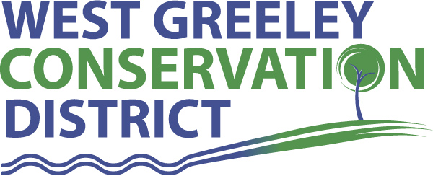
Board of Supervisors
Meeting Agenda

Monday, January 9, 2023

11:00 AM

4302 W 9th Street Rd
Greeley, CO 80634

Welcome, roll call, and meeting called to order:
Introduction of Guests: NONE
Approval of Board Meeting Minutes from Regular Meeting December 2022
( ) ( )
Approval of December 2022 Treasurers Report and Financial Statements
( ) ( )
Approval of Payable for December 2022
( ) ( )
Staff Reports
- Staff
- Liz Schneider, Conservation Technician

- Jasen Kettle, Houston Garden Coordinator

- LeRoy D. Hall, Conservation Technician

- Taylor Webb, Community Engagement Specialist

- Ryan Kapperman, Field Technician

- Bruce Cameron, Seasonal Technician

Partner Reports
NRCS Report: Will Owsley, Resource Team Leader

CSU Extension Report: Hannah Swanbom ED/CSU Extension

New Business/Request for Financial Support
- WGCD Ag Symposium – any caps for speaking engagements
- 5% Employee Salary Reviews – as presented
- COLA increase of 4.87%
- Anderson & Whitney 2022 Audited Financials - $15,000
- Farm Show – January 24-27 @ Island Grove
- Carpet Cleaning Estimate for Building - $1859
- Mainline Sewer Back Up and further recommendation for cleanup
- Colorado Ag in the Classroom Sponsorship for 2023 - $10,000
- Potential Tractor Purchase
- Lateral Ditch Cost Share - Miles Lateral $20,000

Unfinished Business

- Greenhouse Project Update – photos and payment completed ($71,450)
- Vencing Consideration – potential interested constituents

Weld County Referrals ( ) ( )

- Little Platte Farm, LLC LLA22-0043 Lot Line Adjustment of Lot A RE-3849 and Lot B RE-1522.
- Greg Johnson LLA22-0039 Lot Line Adjustment

NRCS Referrals
( ) ( )

Referral Request

- Town of Severance. Clearview Library District- Branch Library at 7 Timber Ridge Parkway.
- Severance Storage 10845 WCR 74

Annexation Notifications:
- Town of Severance: NONE
- Town of Milliken: NONE
- Town of Ault: NONE

PUBLIC HEARING
- NONE
BIO SOLID PERMIT: None

REMINDERS
- Board Members should turn in mileage Reimbursements.
- Next Meeting is Monday, February 13, 2023, WGCD 4302 W 9th Street Rd, Greeley, CO 11:00 am
- Upcoming Holiday/Office Closures: January 16, 2023 – MLK, Jr Day; February 20 – President’s Day

Executive Session: Time is set aside to adjourn the open meeting and go into executive session in accordance with (CRS 24-6-402 (4) (f).
1:00 pm Adjournment

Board Members Present Partners Present

( ) John Leone ( ) Will Owsley - NRCS
( ) Lenny Simpson ( ) Hannah Swanbom
( ) Tony Becker ( )
( ) Allen Beloin
( ) Dale Souther

Staff Members Present Guests Present

( ) Jasen Kettle ( )
( ) Kandee Nourse
( ) LeRoy Hall
( ) Liz Schneider
( ) Ryan Kapperman
( ) Taylor Webb

