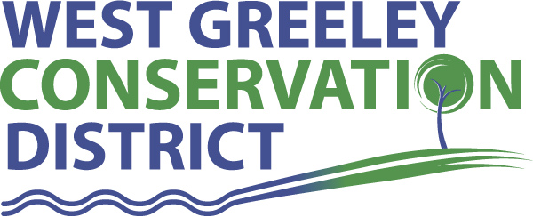
Livestock Well Cost-Share Application

Applicant name:______________________________________________ Date of Application: ___________

Address:______________________________________________________________

Phone:_________________________________________ Email: _____________________________________

SSN:________________________________________________
Resource concern you are addressing:

Cost share practice applying for: ____________________________________________________

Requested Cost share amount: _______________________

Total Project Cost: _______________________

*Office use only* Project summary and technician notes: (attach plans, maps or technical design if required):

I certify that I have read and understand the program provisions listed with this application

Applicant Signature __________________________________________ Date: ___________

WGCD personnel____________________________________ Date______________

*Completed applications are reviewed the second Monday of each month.

Updated 4/10/23

Qualifications for Livestock Well

- All wells to be cost-shared must currently be on land within the WGCD.
- Limit 1 cost share approval per category, per property, per 10-year period. (For repeat customers, the ten-year period begins after you receive payment from WGCD for previous cost share.)

- All wells to be cost shared must be approved by the WGCD, and be installed in accordance with the Natural Resources Conservation Service’s (NRCS) standards and specifications, and be accompanied by an approved grazing management plan that enhances conservation needs of the land and/or district.
- Cost-Share contract must be signed and returned to WGCD prior to any work being done on the
livestock well.

- Landowners are responsible for obtaining their own State permits prior to construction. Landowners are also responsible for submitting a Well Test and Construction Report along with itemized bills once construction is complete.

- No representation is made by WGCD as to the existence or non-existence of underground hazards. Landowners are responsible for location of underground utilities, and supplying WGCD personnel with the UNCC reference number for the project, at least 2 days prior to construction. Utilities participating in Utility Notification Center of Colorado (UNCC) can be notified at 1-800-922-1987.

- The minimum acreage of range/pasture to be serviced by the well shall not be less than 140 acres.

- The district will cost share 50% (not to exceed the USDA’s Weld County cost docket per foot) of the cost of the livestock well up to a maximum of $10,000 per landowner. Any additional costs will be the sole responsibility of the landowner.

- The well program is designed for livestock wells only. The well may be used for livestock only for a period of five years. Thereafter, the well may be used for other purposes as well as livestock water. If the well is used for any purpose other than livestock water within five years after the completion the cost share amount must be repaid to the District.

- Applicants are encouraged to install solar electric pumps on new cost share wells.

- If on CRP land, CRP contract must expire within two years of application.

- Prior to implementation must speak with NRCS Range Conservationist about your grazing plan.
- The landowner will be paid after the well has been installed and inspected by the District or NRCS, and submits a copy of SSN or Tax ID and an itemized bill.

- Program cost share will not exceed 100% of well drilling and casing cost when used in combination of other programs or insurance payments.

