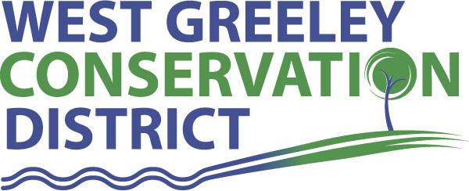
SMALL ACREAGE IRRIGATION WATER IMPROVEMENT COST SHARE
The goal of the small acreage irrigation cost share is to provide irrigation improvements to smaller landowners that are within the West Greeley Conservation District. All participants must be active taxpayers of the West District Conservation District. Updated 4/10/23
Requirements for irrigation cost share: The land must be within the WGCD
- Cost Share form must be completed and returned to WGCD. The form will be taken to the Board of Supervisors for discussion and approval. Quotes for desired work must be submitted with Cost Share form and submitted to WGCD. Proof of irrigation water ownership must be provided to WGCD
- Limit 1 cost share approval per category, per property, per 10-year period. (For repeat customers, the ten-year period begins after you receive payment from WGCD for previous cost share.)
- All projects must be approved by WGCD Board of Supervisors prior to any work being done on property. If you begin working on improvements before approval, you will be disqualified from Cost Share.
- All cost shared improvements must be installed in accordance with the Natural Resources Conservation Service’s (NRCS) standards and specifications.
- Irrigation water right ownership must be provided by the owner of the property. Irrigation water must have been used for 4 of the 6 previous years. WGCD DOES NOT authorize cost share to anyone without current ownership of IRRIGATION WATER.
- All materials must be new and in new condition for project
- Irrigation water must be utilized for active agricultural production (cropped, hayed or grazed)
- Irrigation improvement/establishment must be used to irrigate in an efficient and conservation minded manor. Irrigation system must be renovated for efficiency. Irrigation system improvements can be used to address soil quality or erosion resource concerns on property.
- Acreage requirement is a maximum of 20 acres
- Any required permits for irrigation changes on property are the responsibility of owner to obtain
- The district will cost share 50% (not to exceed the USDA’s Weld County cost docket per foot) of the cost of the project up to a maximum of $10,000 per landowner. Any additional costs will be the sole responsibility of the landowner.
- No representation is made by WGCD as to the existence or non-existence of underground hazards. Landowners are responsible for location of underground utilities, and supplying WGCD personnel with the UNCC reference number for the project, at least 2 days prior to construction. Utilities participating in Utility Notification Center of Colorado (UNCC) can be notified at 1-800-922-1987.
Applicant name: __________________________________________________________

Date of Application: _______________________________________________________

Address: ________________________________________________________________

Site Location: ____________________________________________________________

Phone: __________________________________________________________________

Email: __________________________________________________________________

SSN: ___________________________________________________________________
Resource concern you are addressing and please describe needs below:

Requested Cost share amount: _______________________
Total Project Cost: _______________________

I certify that I have read and understand the program provisions listed above. *Do we need more waiver of liability

Applicant Signature ___________________________________________ Date: ___________

WGCD personnel_____________________________________________ Date______________
*Completed applications are reviewed the second Monday of each month.

