West Greeley Conservation District
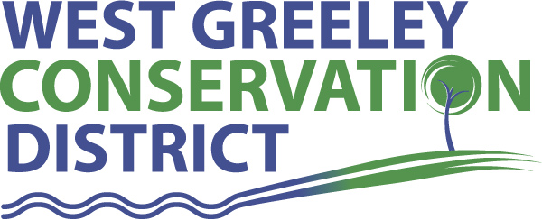
Board of Supervisors
Meeting Agenda

Monday, May 8, 2023

11:00 AM

HOUSTON GARDEN
515 23rd Ave
Greeley, CO 80631

Welcome, roll call, and meeting called to order:
Introduction of Guests:
Approval of Board Meeting Minutes from Regular Meeting April 2023
( ) ( )
Approval of April 2023 Treasurers Report and Financial Statements
( ) ( )
Approval of Payable for April 2023
( ) ( )
Staff Reports
- Staff
- Liz Schneider, Conservation Technician

- Jasen Kettle, Houston Garden Coordinator

- LeRoy D. Hall, Conservation Technician

- Taylor Webb, Community Engagement Specialist

- Ryan Kapperman, Field Technician

- Bruce Cameron, Seasonal Technician

Partner Reports
NRCS Report: Will Owsley, Resource Team Leader

CSU Extension Report: Hannah Swanbom ED/CSU Extension

FSA Acting Supervisor Report: Shelley Woods

New Business/Request for Financial Support
- Cost Share Consideration
- Snell, Ed – CRP Recovery
- Foss Dairy Farm LLP (B. & R. Meireis) – Cover Crop Cost Share
- Craven, Rex – Any consideration for a Ditch repair

- Oath of Office
- John Leone
- Anthony Becker
- Lennard Simpson

- Camp Rocky Applicants

- Petition into the District – Forster, John and Gwen
34749 CR 68, Briggsdale, CO

- Civil Rights Responsibilities for Partners Checklist

Unfinished Business

- Tree Sale
- Pick Up Orders Week of May 15

- Tractor Purchase Update

- Children’s Sensory Equipment at Houston Garden $16,000 - $20,000 range

- Scholarship Candidate Consideration

- Raegan Johnson Windsor High School + Adams State – Ag Business
- Cole Halley Platte Valley High School + NJC – Pre-Engineering/precision ag
- Lane Steven Highland High School + NJC – Ag Ed
- Robert Meireis Platte Valley/CSU – Soil and Crop Science/Ag Business

- Greenhouse Project Update
- AB Dirtworks - $1615.50
- AB Dirtworks - $ 1062.00

- Virtual Fencing

- Ranching for Profit Workshop

- Audit Still Ongoing

- ADA Website compliance Update

Weld County Referrals
- Applicant: : CMH Homes, Inc. Case Number: FFD23-0009
Project: FAMILY FARM DIVISION – NORTH
- Applicant: CMH Homes, Inc Case Number: FFD23-0010
Project: FAMILY FARM DIVISION – SOUTH
- Applicant: Gene and Janine Oblander Case Number: LLA23-0003
Project: LOT LINE ADJUSTMENT BETWEEN LOT A AND LOT B OF RE-834
- Applicant: WELD COUNTY SCHOOL DIST RE-9 (73%)
Case Number: LLA23-0008
Project: LOT LINE ADJUSTMENT BETWEEN RE-9 AND AULT FIRE
- Applicant: Wendy Winter, c/o PDC Energy, Inc
Case Number: ZPTT23-0006
Project: ZONING PERMIT FOR 40' TELECOMMUNICATION TOWER
- Applicant: PIERCE WALTER T Case Number: FFD23-0012
Project: FAMILY FARM DIVISION ON 39 ACRES

NRCS Referrals: NONE
( ) ( )

NOTICE Consideration of Construction Materials Reclamation Permit Acreage Release Request Application

Annexation Notifications:
- NONE

PUBLIC HEARING
- NONE
BIO SOLID PERMIT: None

REMINDERS
- Board Members should turn in mileage Reimbursements.
- Tree Sale week is May 15-19, 2023
- Next Meeting is Monday, June 12, 2023
- Coalbank Dam Inspection Monday, June 12, 2023 @ 9:00am

Executive Session: Time is set aside to adjourn the open meeting and go into executive session in accordance with (CRS 24-6-402 (4) (f).
1:00 pm Adjournment

Board Members Present Partners Present

( ) John Leone ( ) Will Owsley - NRCS
( ) Lenny Simpson ( ) Hannah Swanbom
( ) Tony Becker ( ) Shelley Woods
( ) Allen Beloin
( ) Dale Souther

Staff Members Present Guests Present

( ) Jasen Kettle ( )
( ) Kandee Nourse
( ) LeRoy Hall
( ) Liz Schneider
( ) Ryan Kapperman
( ) Taylor Webb
( ) Bruce Cameron

